Video - I. dio (dodavanje rezultata, loga i URL linka projektnoj kartici; podnošenje projektne kartice na pregled programskim djelatnicima Agencije): https://www.youtube.com/watch?v=GITfhwUbUso&feature=youtu.be
Video - II. dio (unošenje promjena nakon zahtjeva programskog djelatnika Agencije): https://www.youtube.com/watch?v=jrsA10DRSkU&feature=youtu.be

Slide 1 - Slide 1
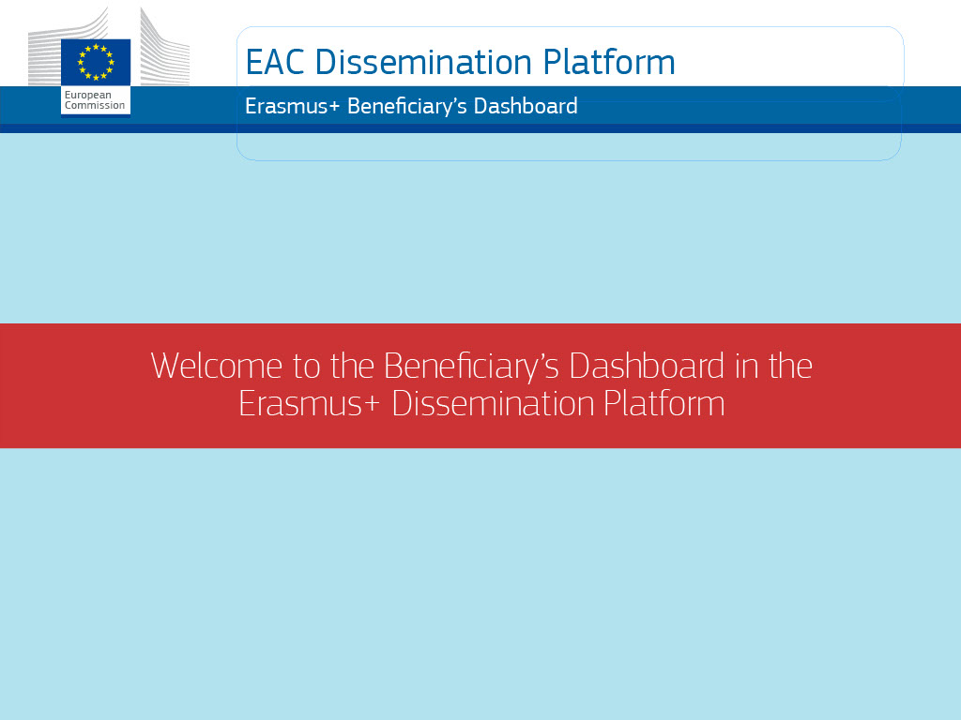
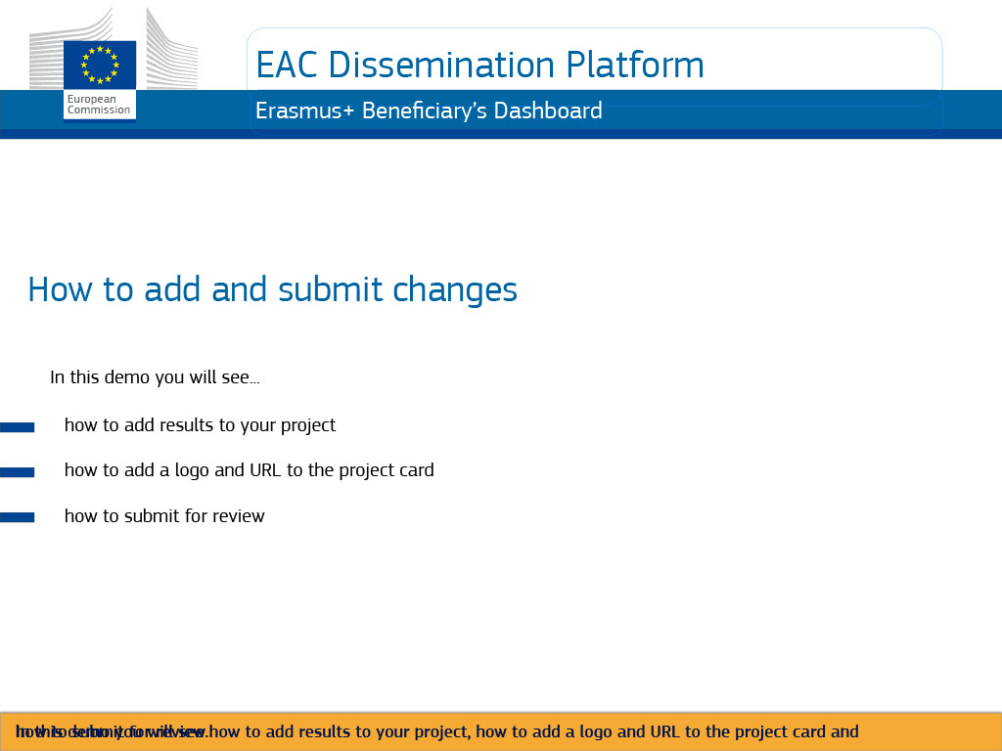
Text Captions

EAC Dissemination Platform

Erasmus+ Beneficiary’s Dashboard

How to add and submit changes

In this demo you will see how to add results to your project, how to add a logo and URL to the project card and how to submit for review.

Slide 2 - Slide 2
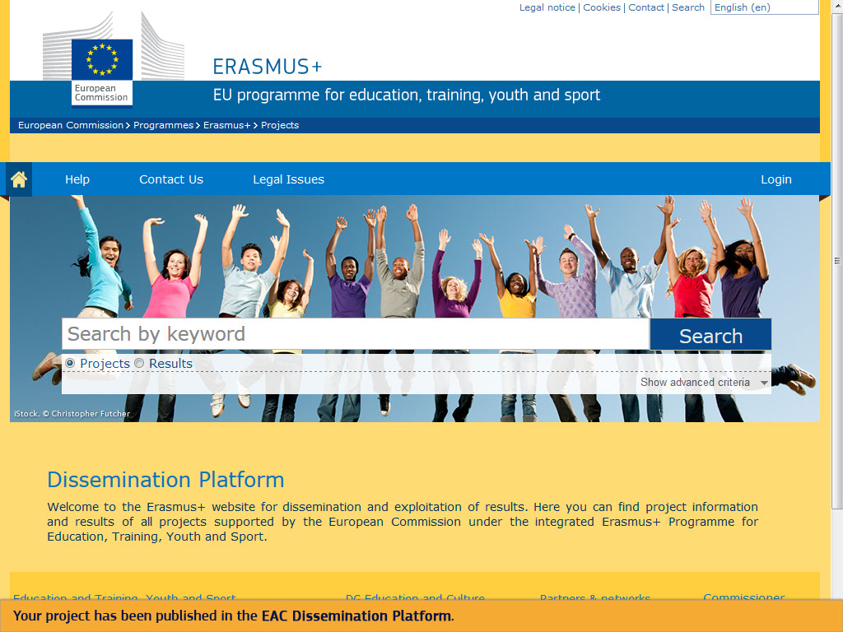
Text Captions

Your project has been published in the EAC Dissemination Platform.

Slide 3 - Slide 3
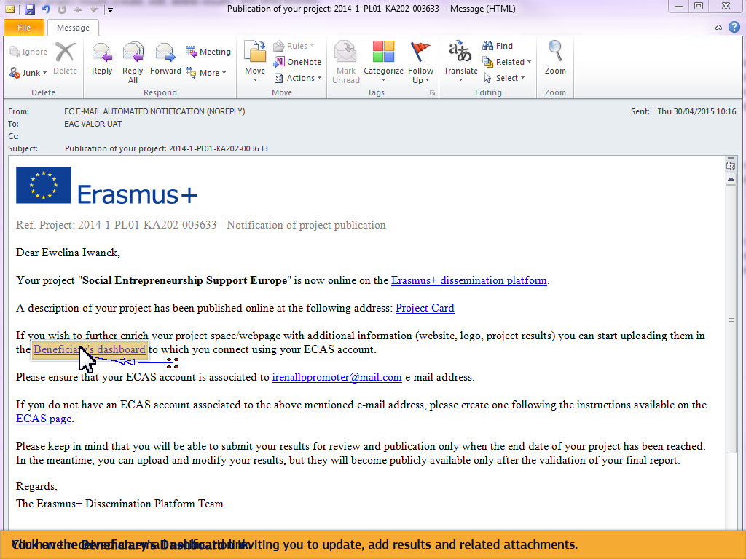
Text Captions

You have received an email notification inviting you to update, add results and related attachments.

Click on the Beneficiary's Dashboard link.

Slide 4 - Slide 4
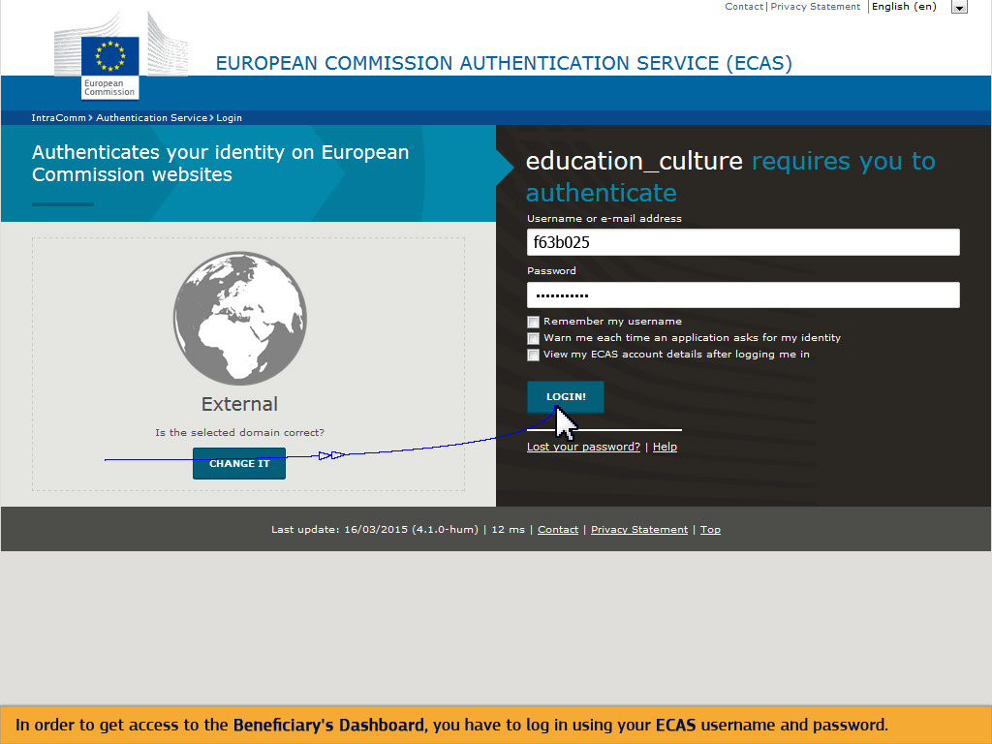
Text Captions

In order to get access to the Beneficiary's Dashboard, you have to log in using your ECAS username and password.

Slide 5 - Slide 5
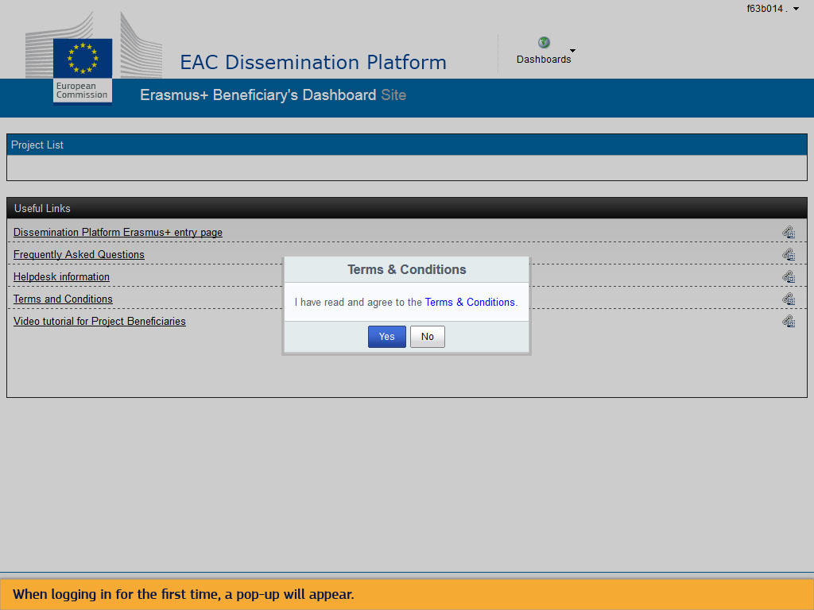
Text Captions

When logging in for the first time, a pop-up will appear.

Slide 6 - Slide 6
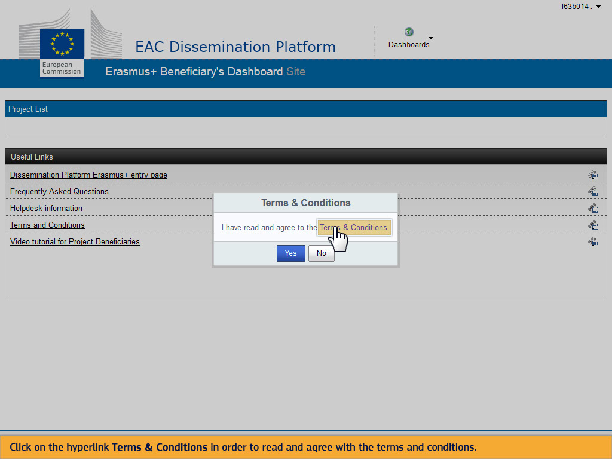
Text Captions

Click on the hyperlink Terms & Conditions in order to read and agree with the terms and conditions.

Slide 8 - Slide 8
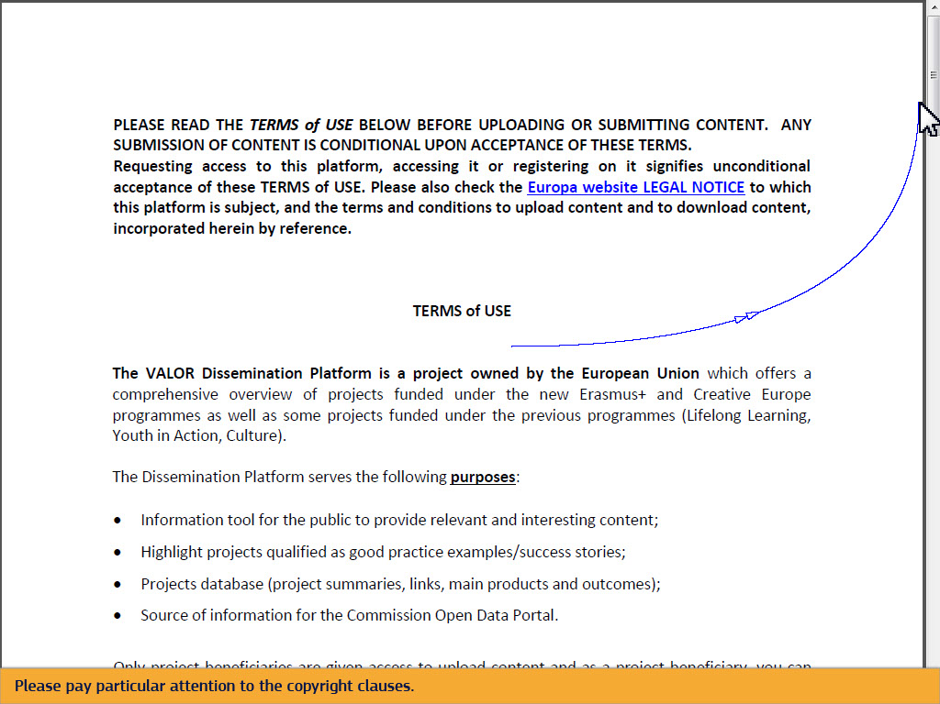
Text Captions

Please pay particular attention to the copyright clauses.

Slide 10 - Slide 10
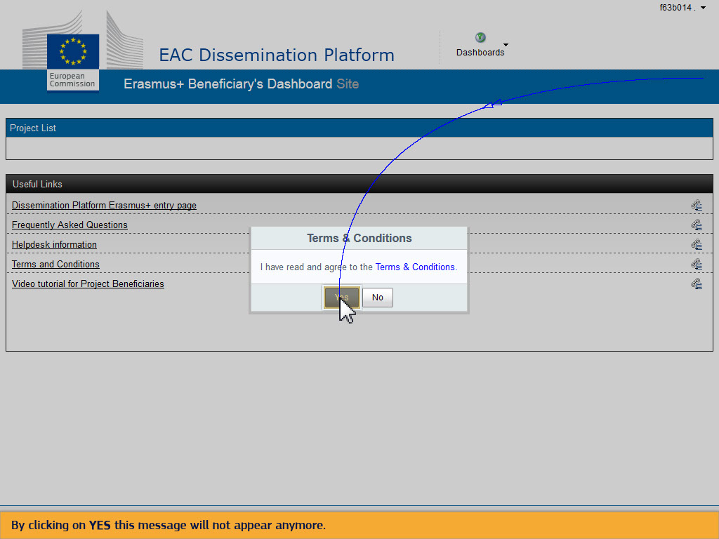
Text Captions

By clicking on YES this message will not appear anymore.

Slide 13 - Slide 13
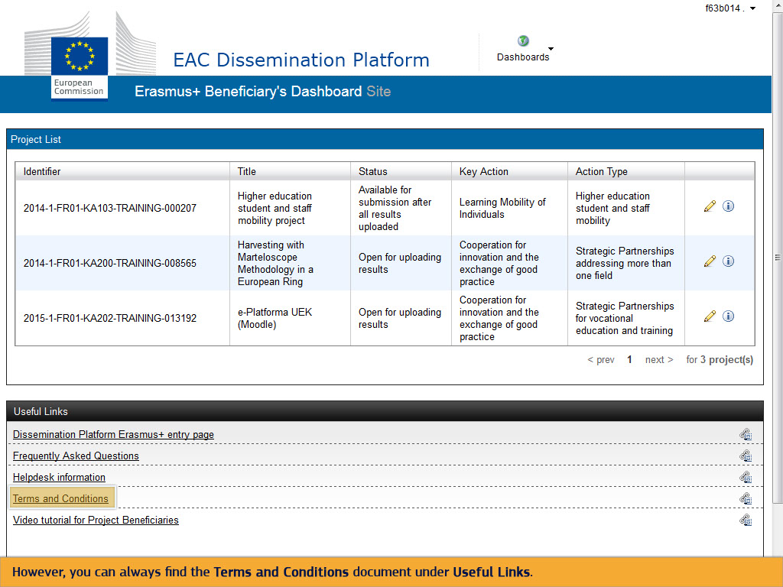
Text Captions

However, you can always find the Terms and Conditions document under Useful Links.

Slide 14 - Slide 14
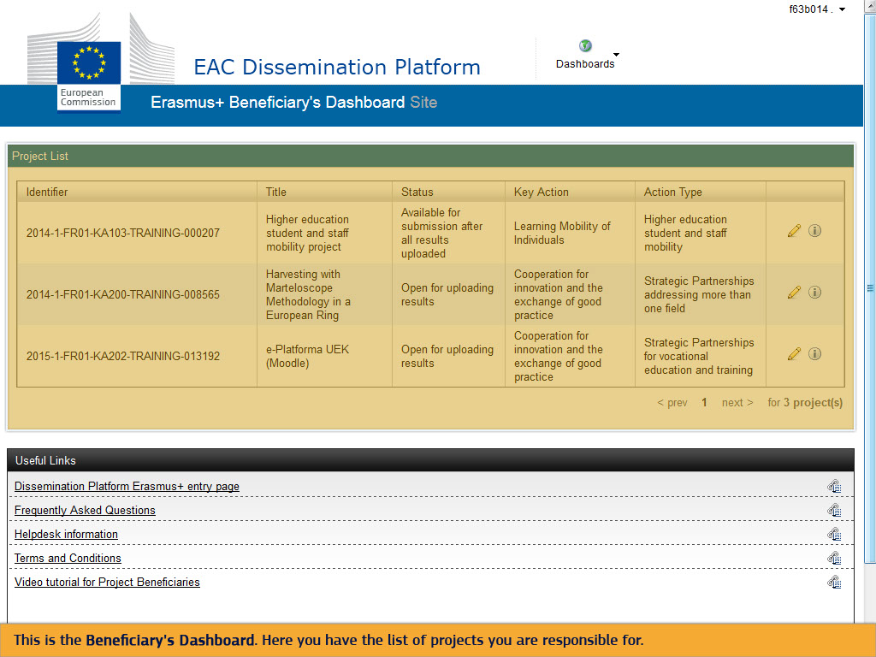
Text Captions

This is the Beneficiary's Dashboard. Here you have the list of projects you are responsible for.

Slide 15 - Slide 15
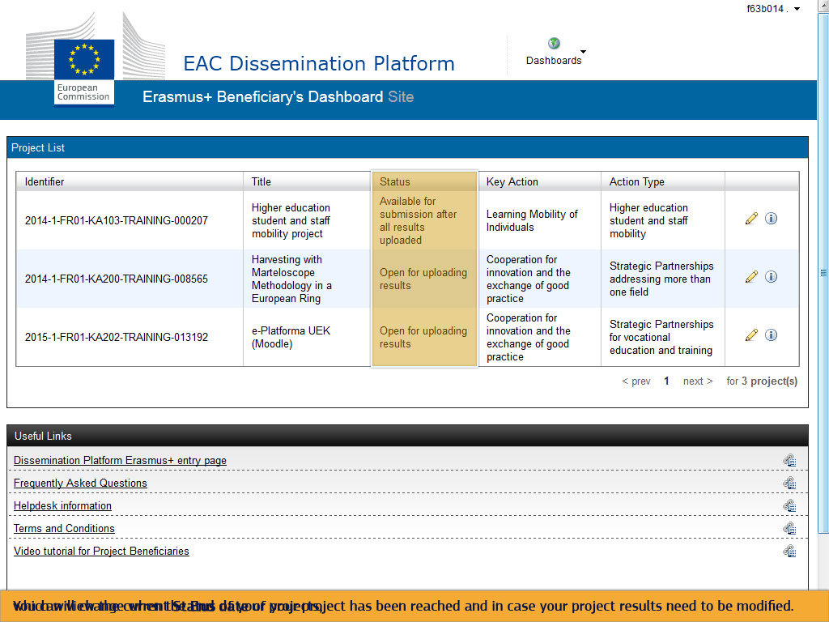
Text Captions

You can view the current Status of your projects, which will change when the End date of your project has been reached and in case your project results need to be modified.

Slide 16 - Slide 16
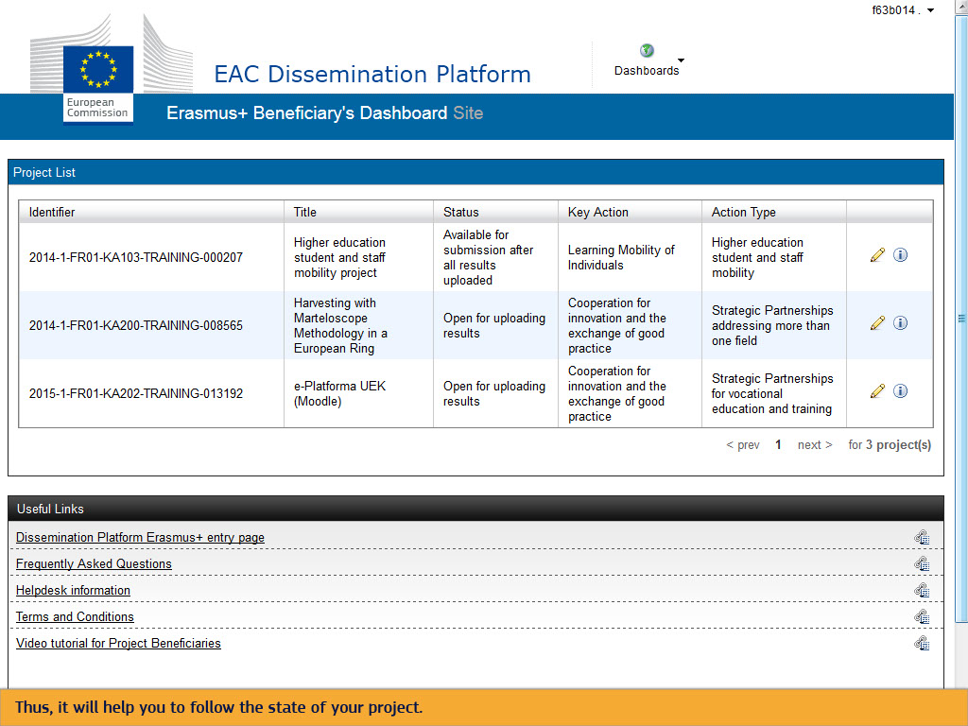
Text Captions

Thus, it will help you to follow the state of your project.

Slide 17 - Slide 17
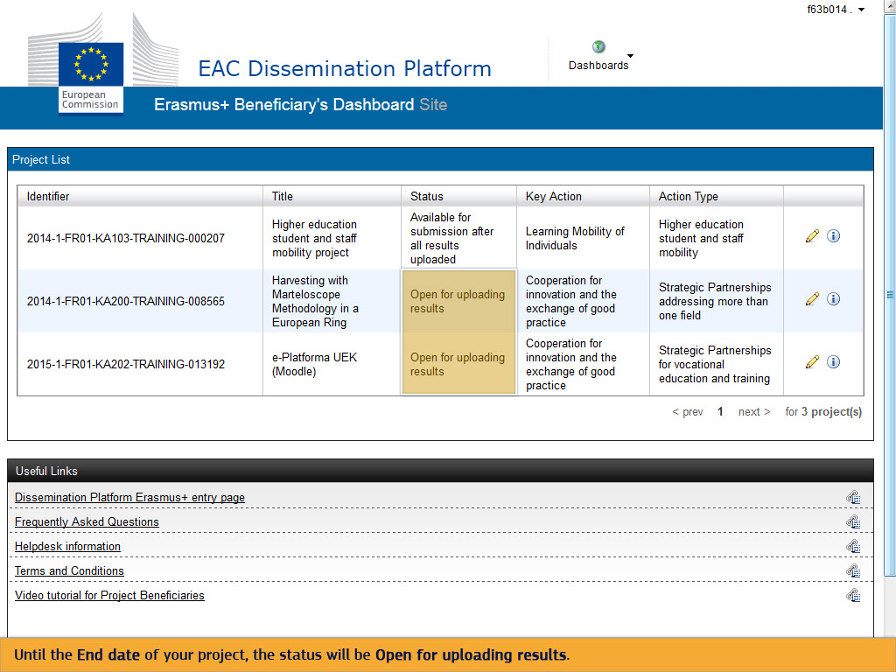
Text Captions

Until the End date of your project, the status will be Open for uploading results.

Slide 18 - Slide 18
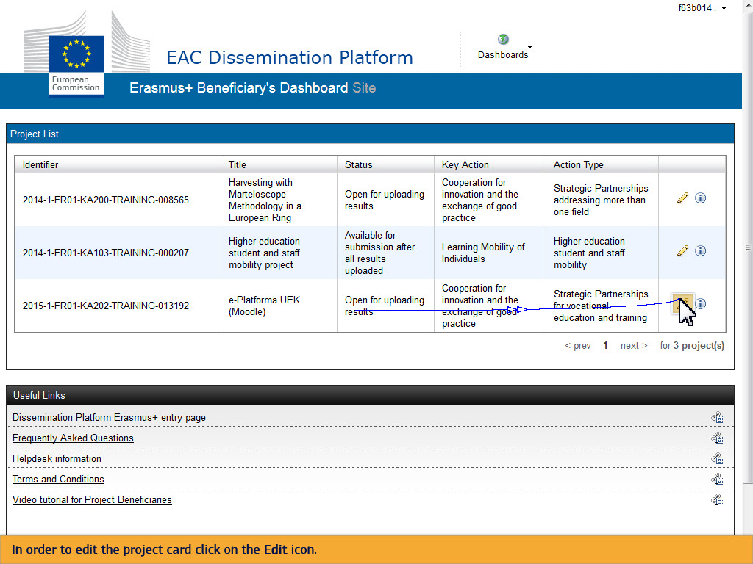
Text Captions

In order to edit the project card click on the Edit icon.

Slide 21 - Slide 21
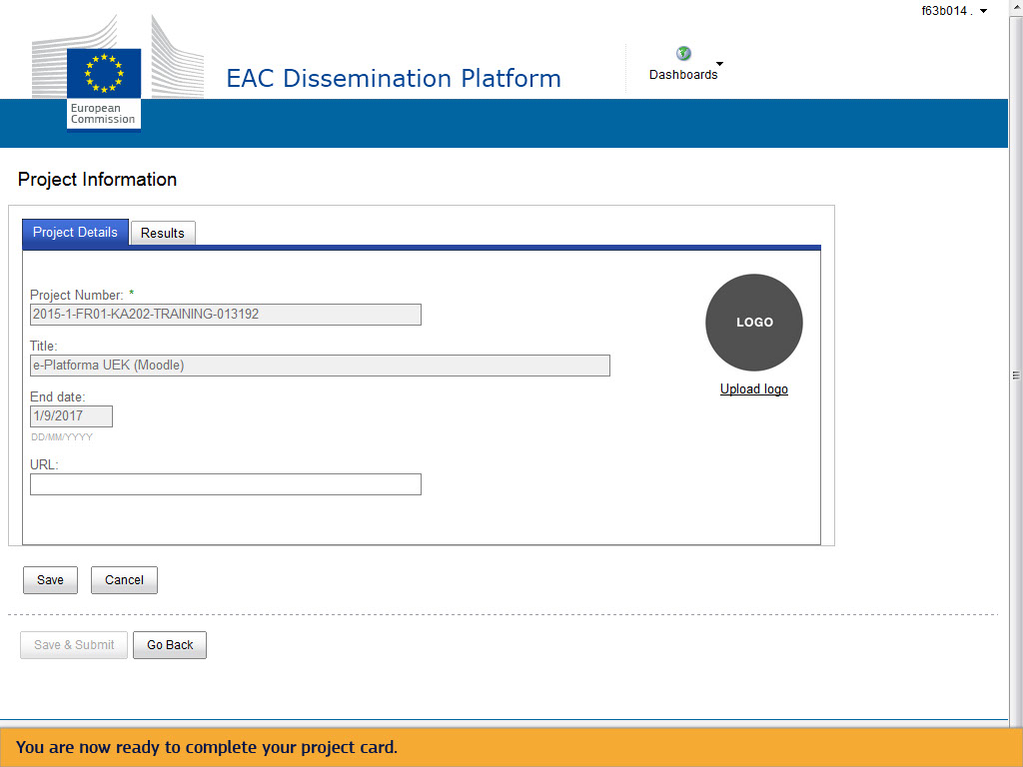
Text Captions

You are now ready to complete your project card.

Slide 22 - Slide 22
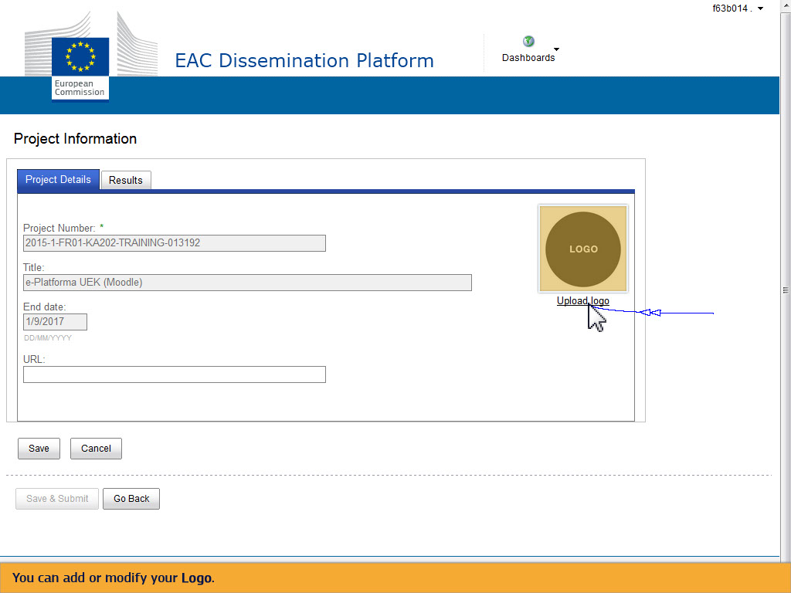
Text Captions

You can add or modify your Logo.

Slide 25 - Slide 25
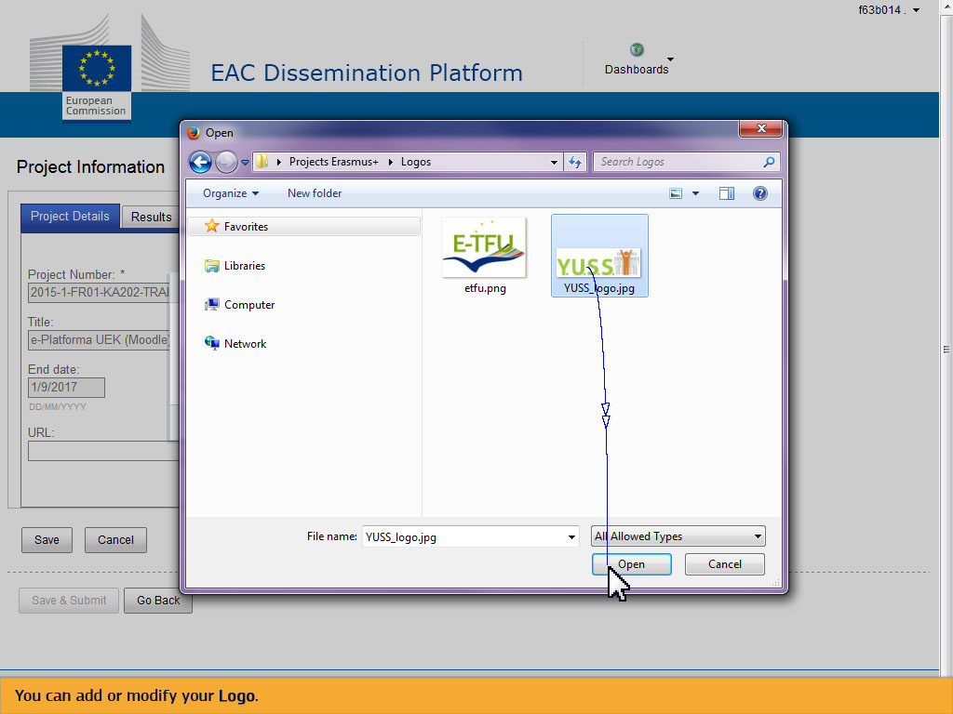
Text Captions

You can add or modify your Logo.

Slide 30 - Slide 30
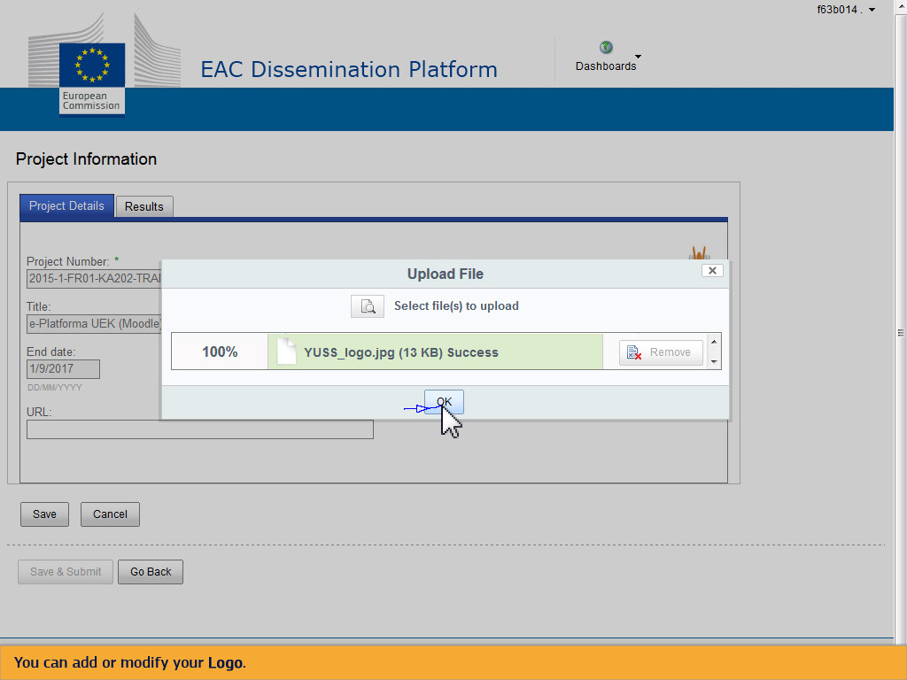
Text Captions

You can add or modify your Logo.

Slide 31 - Slide 31
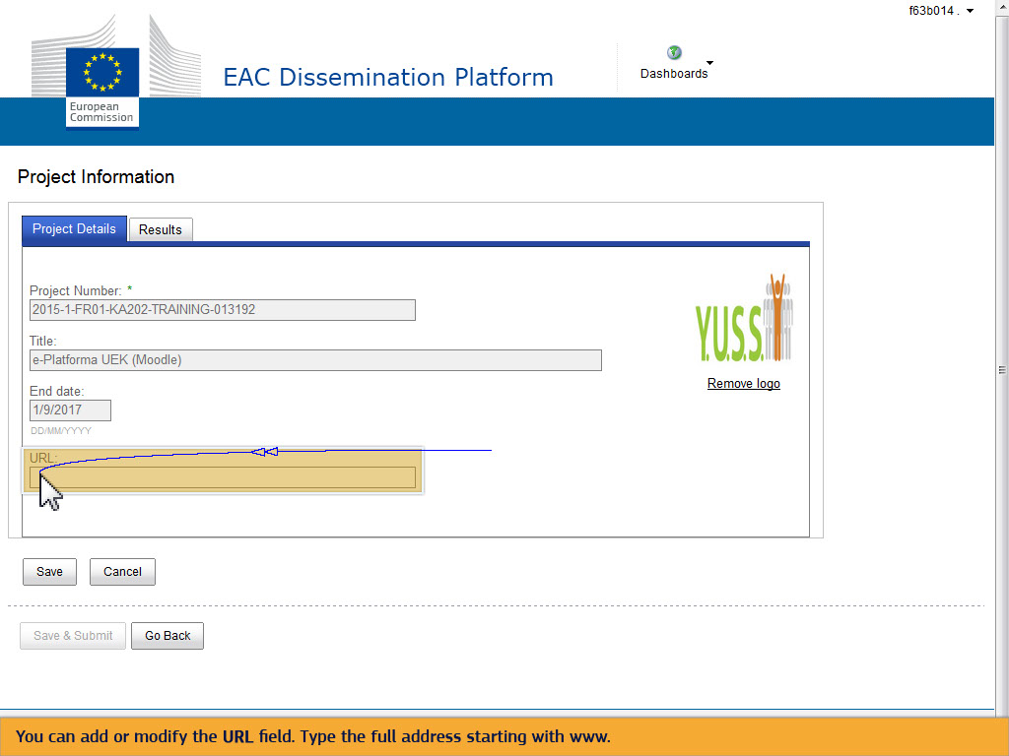
Text Captions

You can add or modify the URL field. Type the full address starting with www.

Slide 32 - Slide 32
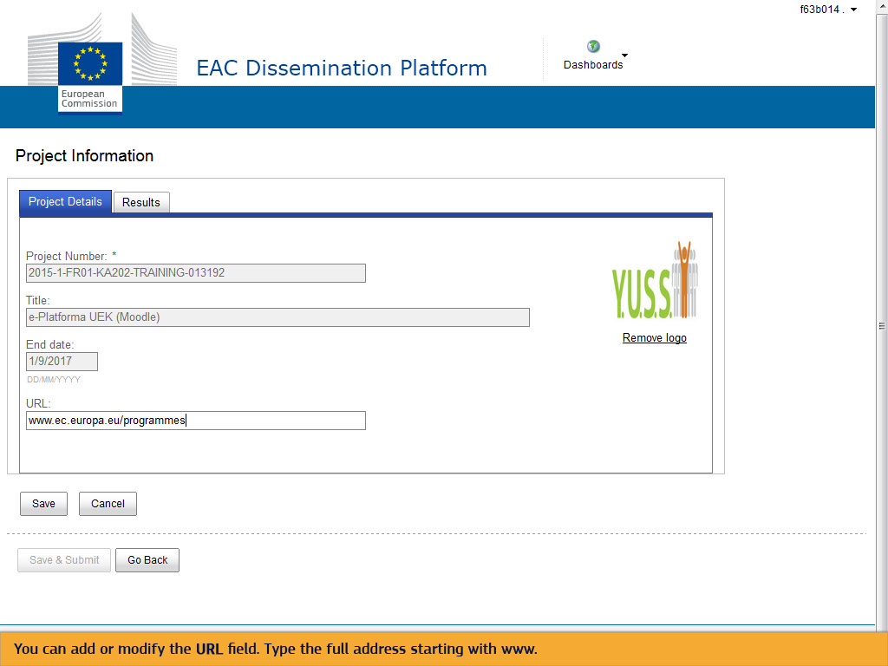
Text Captions

You can add or modify the URL field. Type the full address starting with www.

Slide 33 - Slide 33
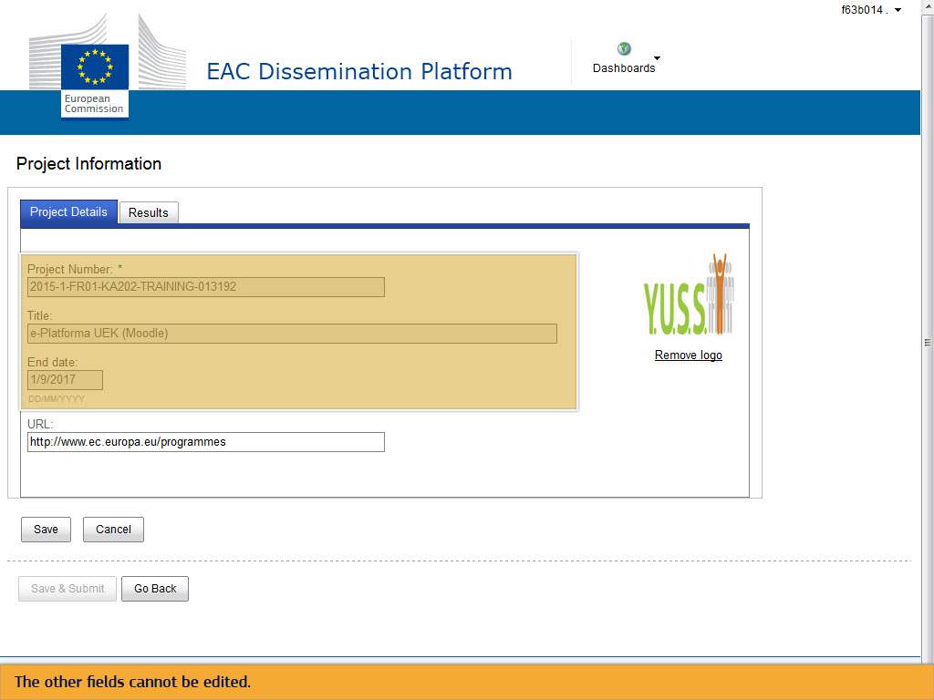
Text Captions

The other fields cannot be edited.

Slide 34 - Slide 34
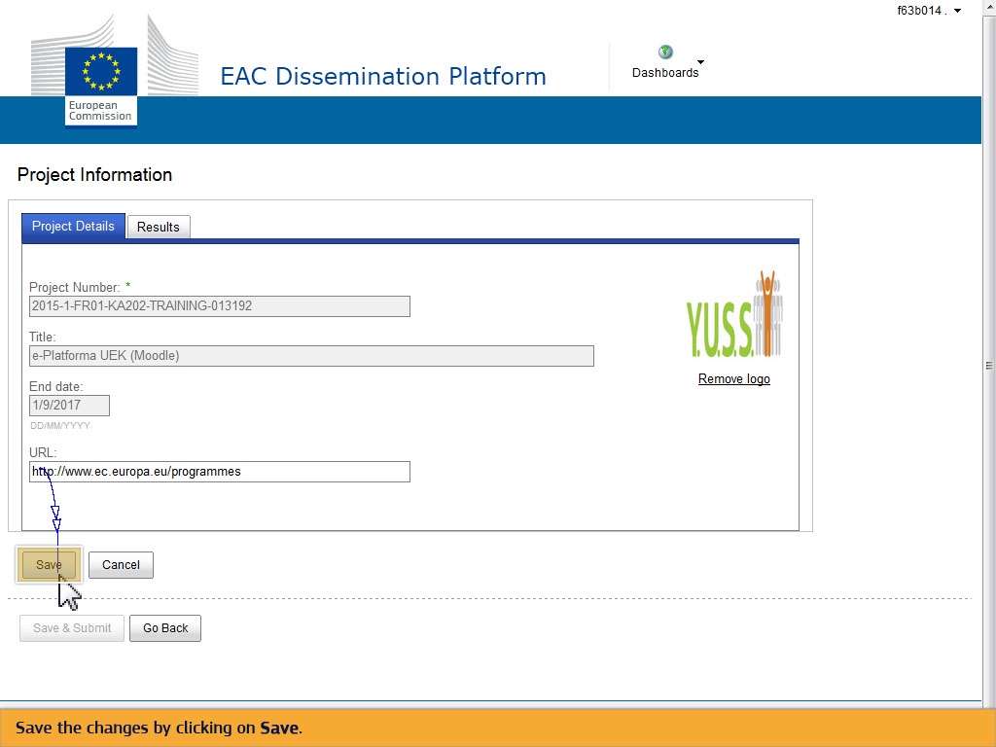
Text Captions

Save the changes by clicking on Save.

Slide 35 - Slide 35
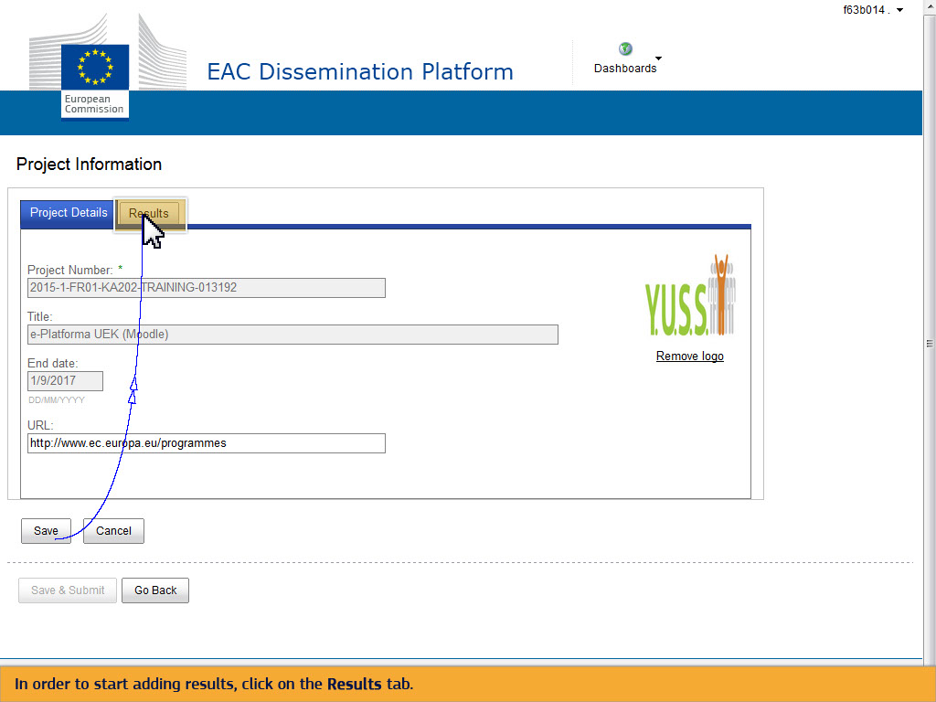
Text Captions

In order to start adding results, click on the Results tab.

Slide 37 - Slide 37
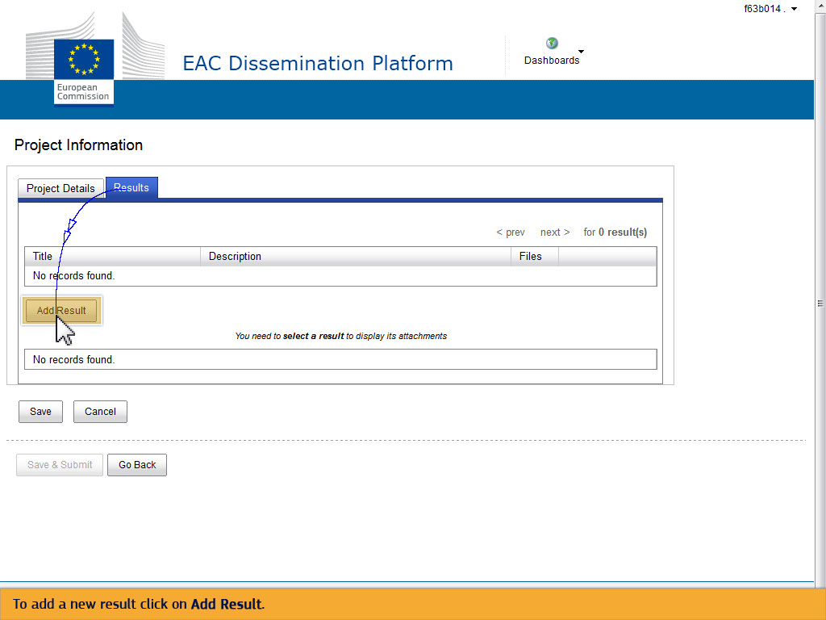
Text Captions

To add a new result click on Add Result.

Slide 38 - Slide 38
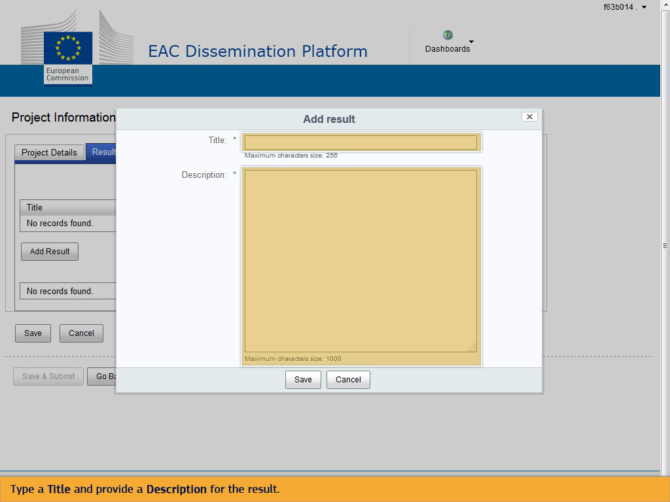
Text Captions

Type a Title and provide a Description for the result.

Slide 43 - Slide 43
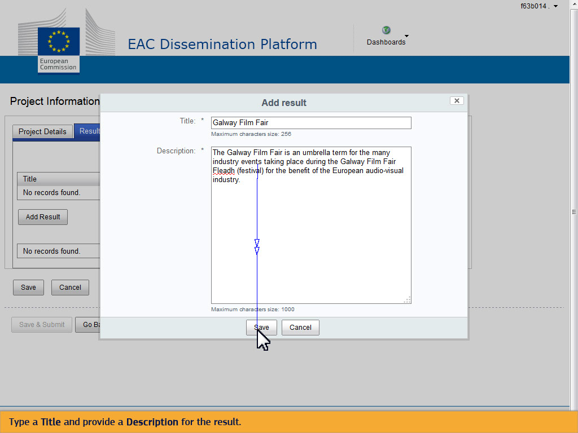
Text Captions

Type a Title and provide a Description for the result.

Slide 46 - Slide 46
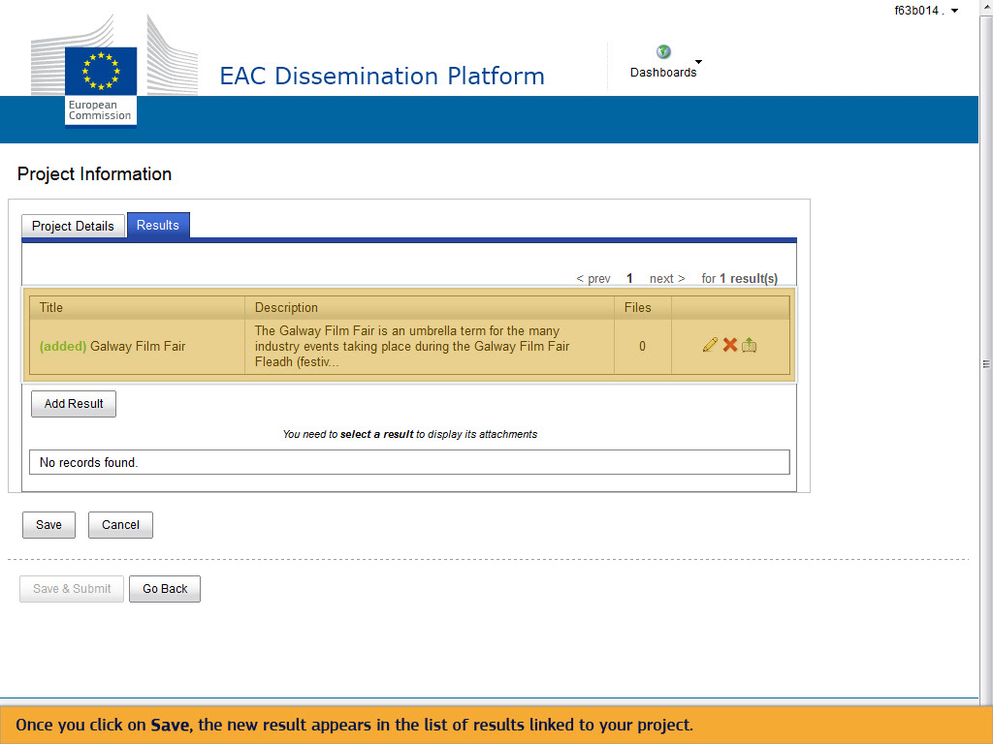
Text Captions

Once you click on Save, the new result appears in the list of results linked to your project.

Slide 47 - Slide 47
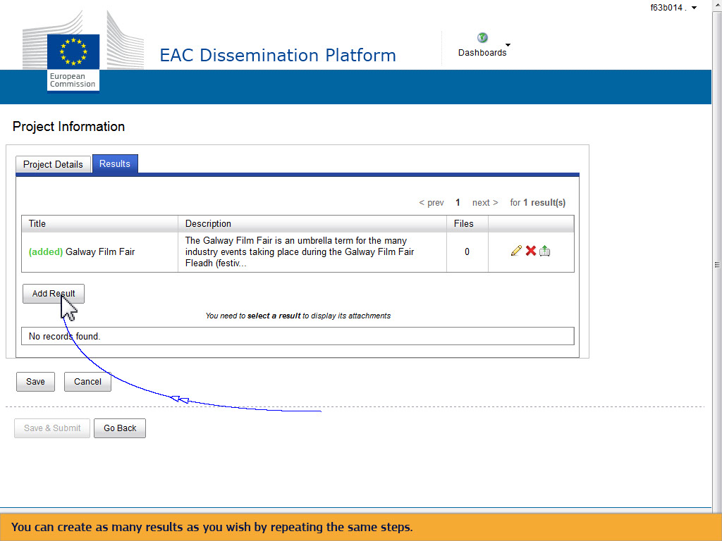
Text Captions

You can create as many results as you wish by repeating the same steps.

Slide 50 - Slide 50
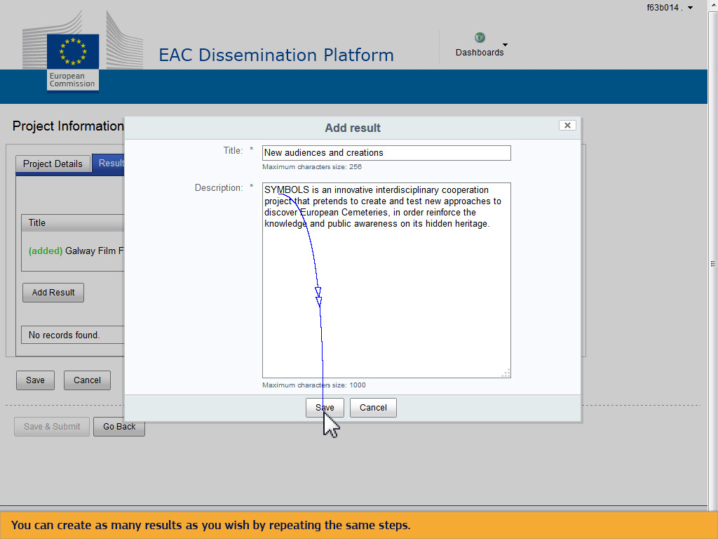
Text Captions

You can create as many results as you wish by repeating the same steps.

Slide 52 - Slide 52
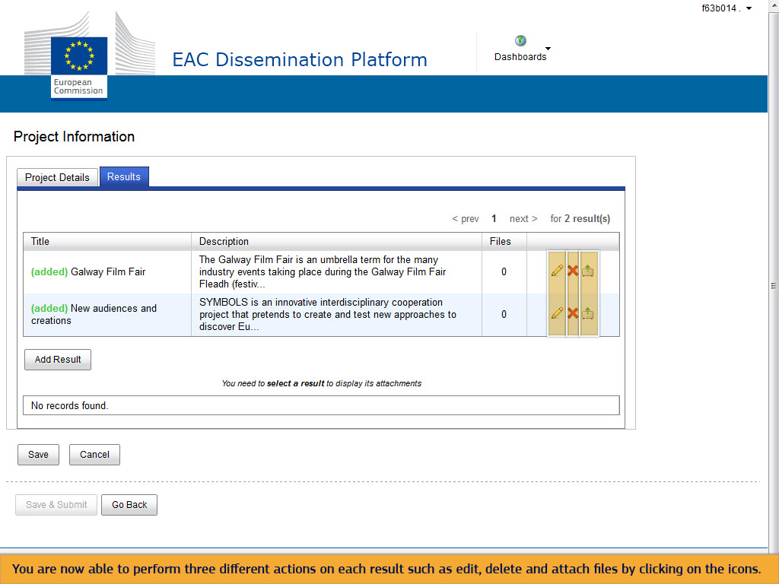
Text Captions

You are now able to perform three different actions on each result such as edit, delete and attach files by clicking on the icons.

Slide 53 - Slide 53
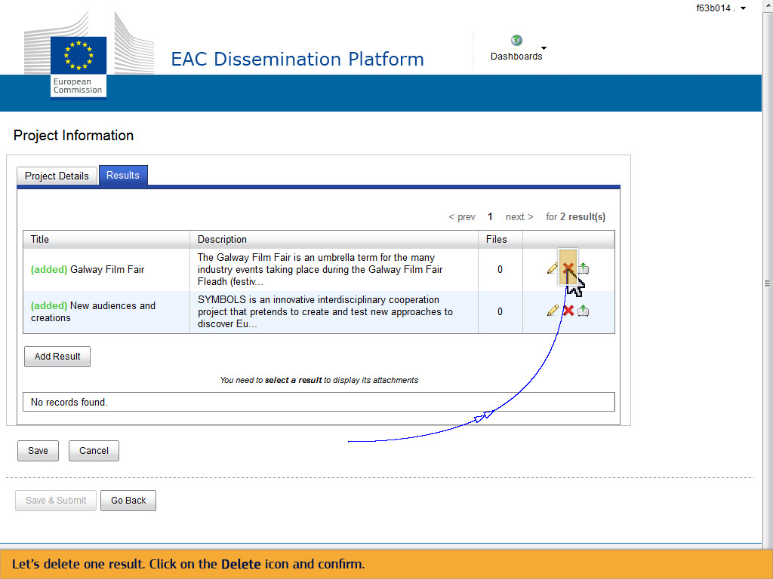
Text Captions

Let’s delete one result. Click on the Delete icon and confirm.

Slide 54 - Slide 54
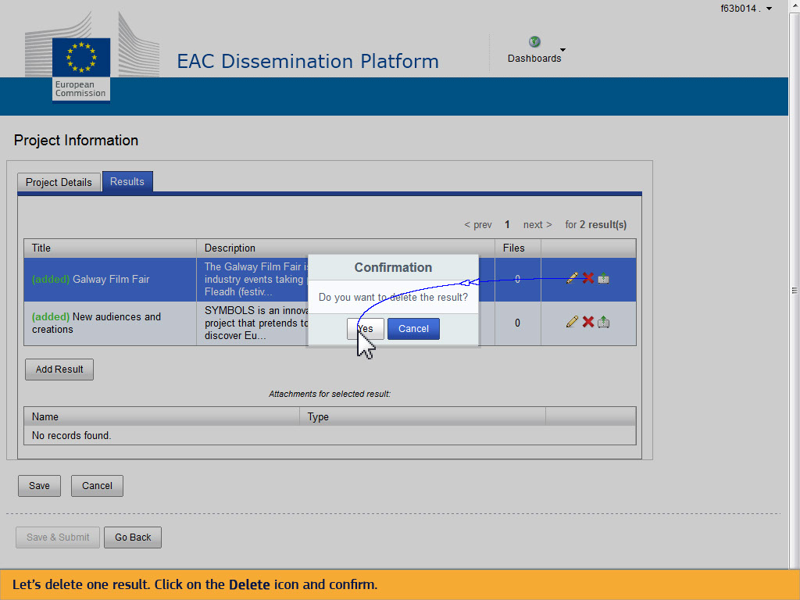
Text Captions

Let’s delete one result. Click on the Delete icon and confirm.

Slide 56 - Slide 56
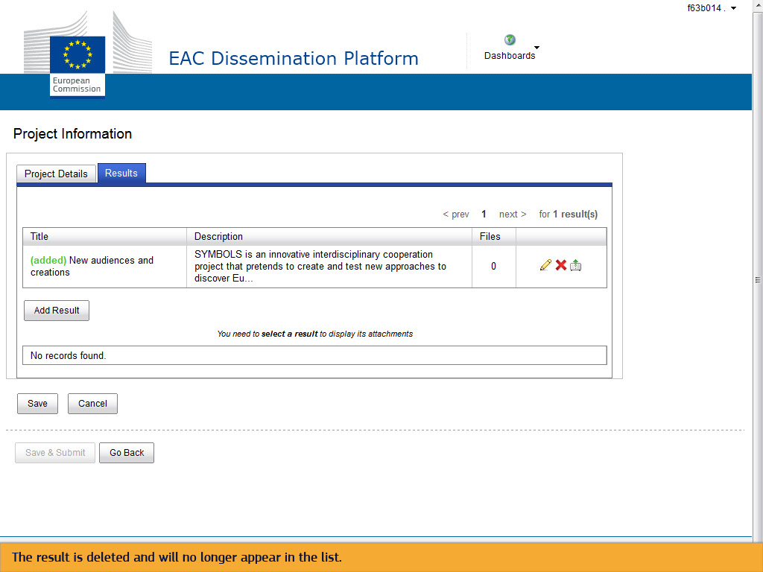
Text Captions

The result is deleted and will no longer appear in the list.

Slide 57 - Slide 57
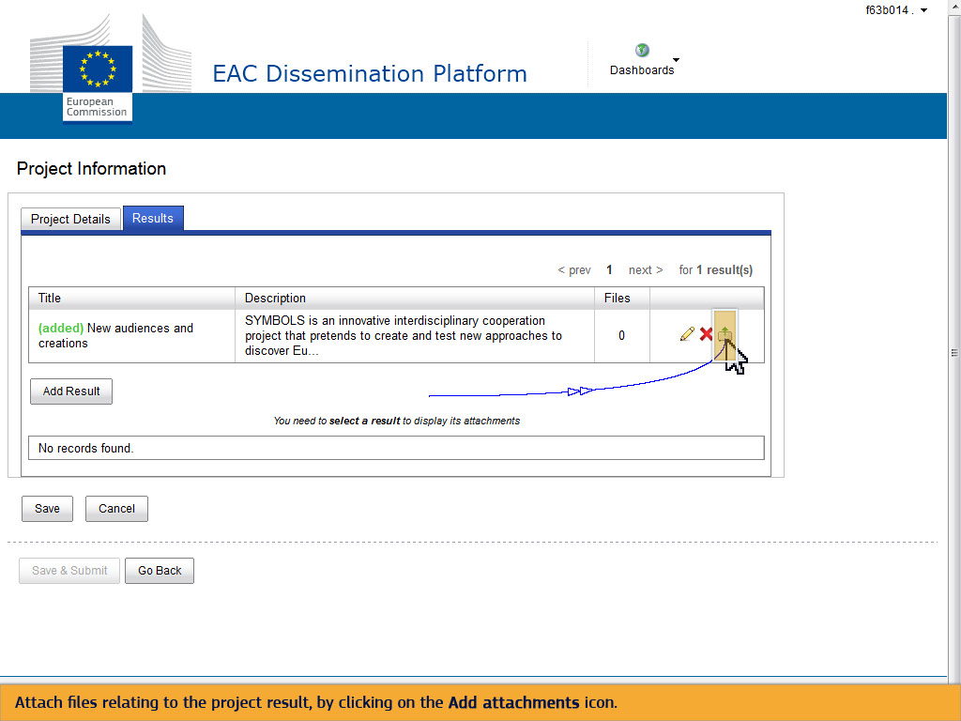
Text Captions

Attach files relating to the project result, by clicking on the Add attachments icon.

Slide 58 - Slide 58
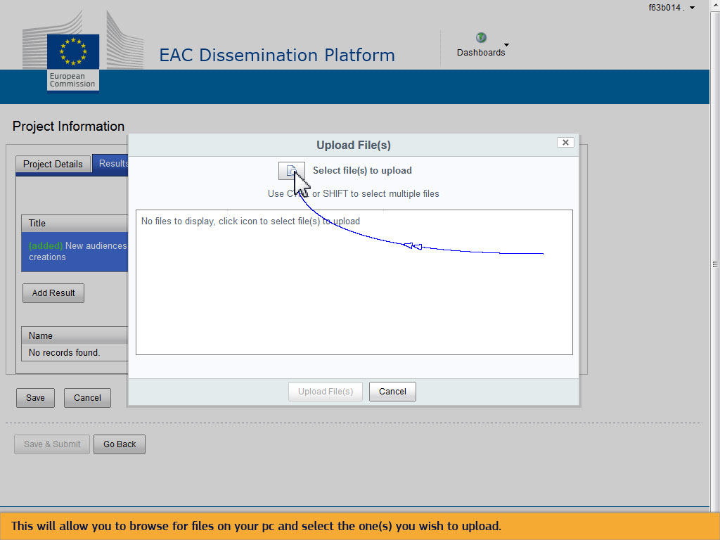
Text Captions

This will allow you to browse for files on your pc and select the one(s) you wish to upload.

Slide 60 - Slide 60
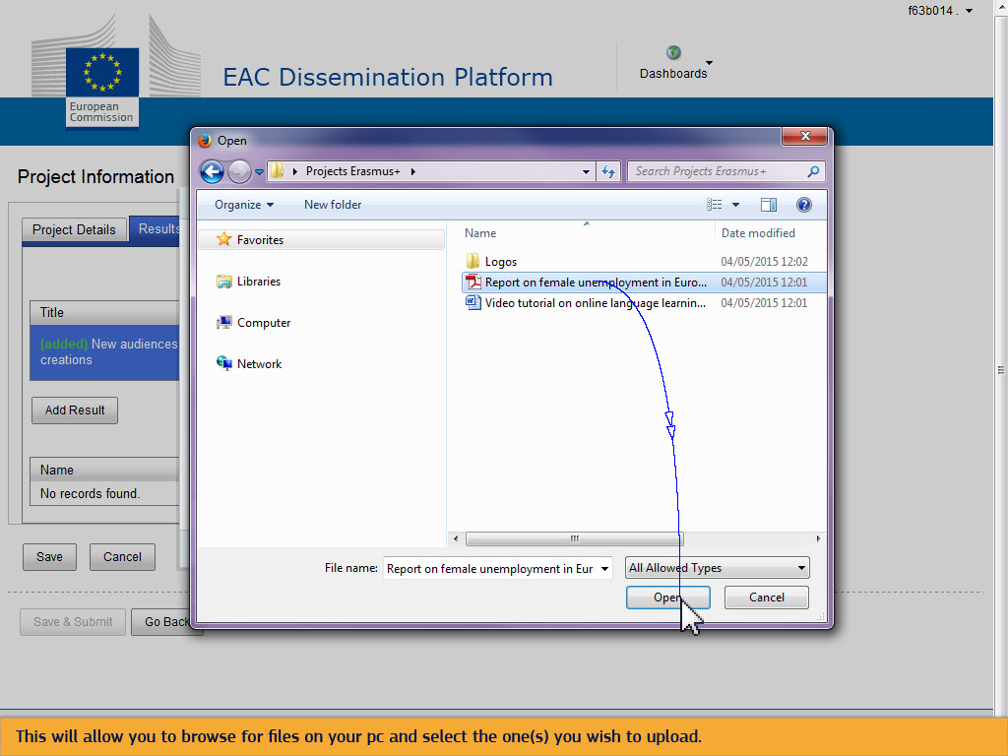
Text Captions

This will allow you to browse for files on your pc and select the one(s) you wish to upload.

Slide 61 - Slide 61
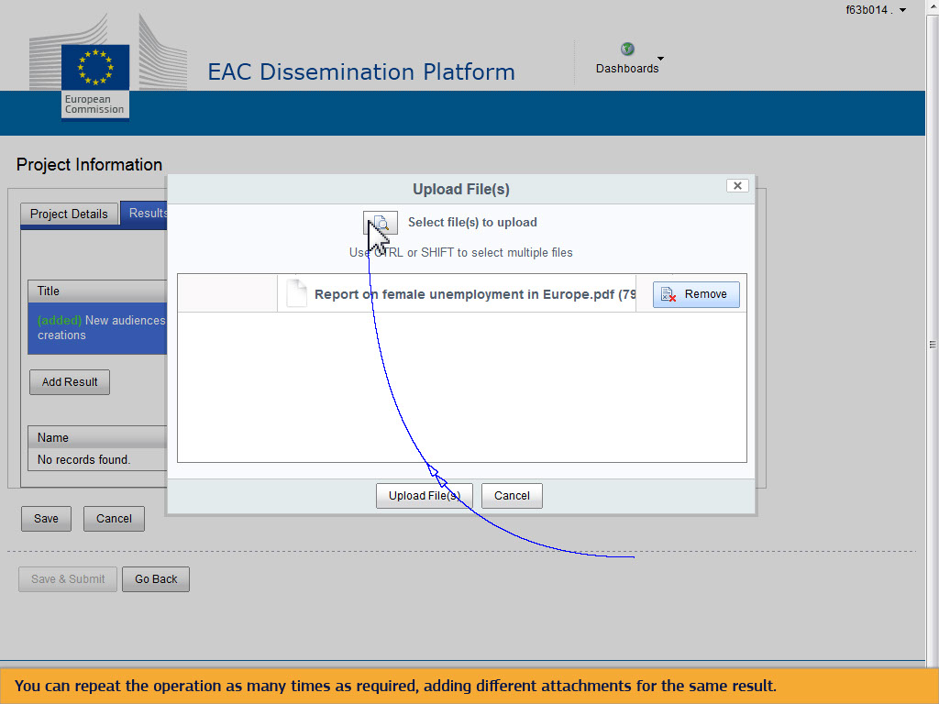
Text Captions

You can repeat the operation as many times as required, adding different attachments for the same result.

Slide 63 - Slide 63
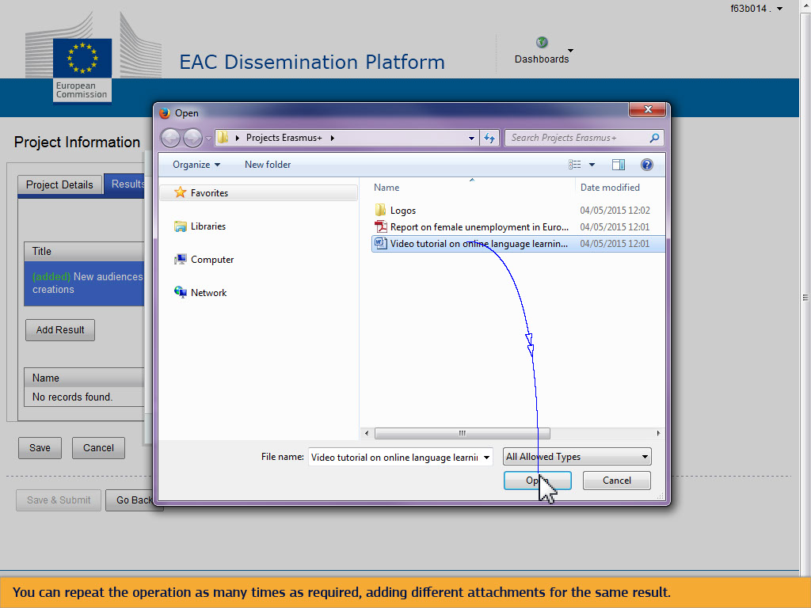
Text Captions

You can repeat the operation as many times as required, adding different attachments for the same result.

Slide 64 - Slide 64
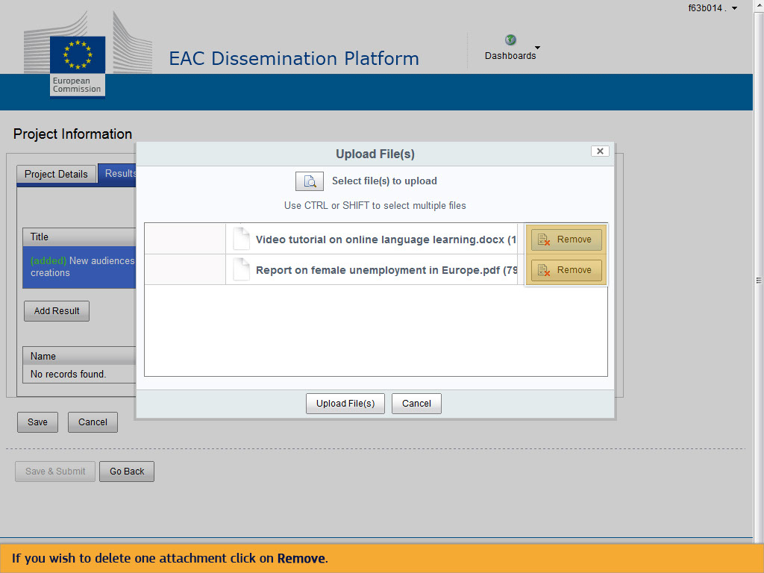
Text Captions

If you wish to delete one attachment click on Remove.

Slide 65 - Slide 65
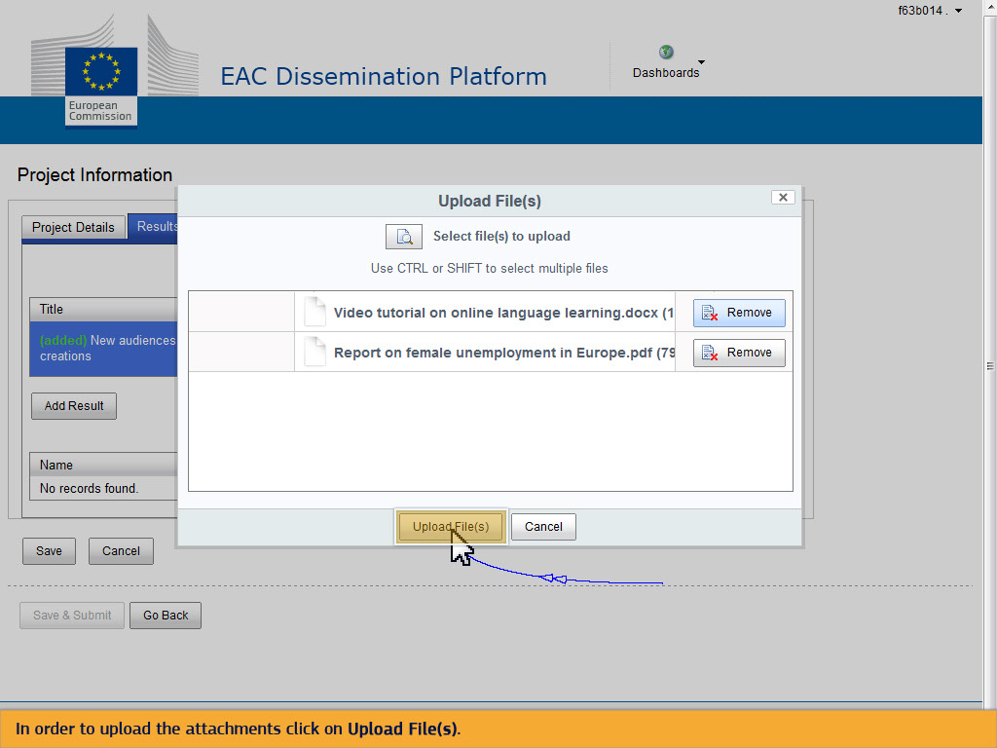
Text Captions

In order to upload the attachments click on Upload File(s).

Slide 66 - Slide 66
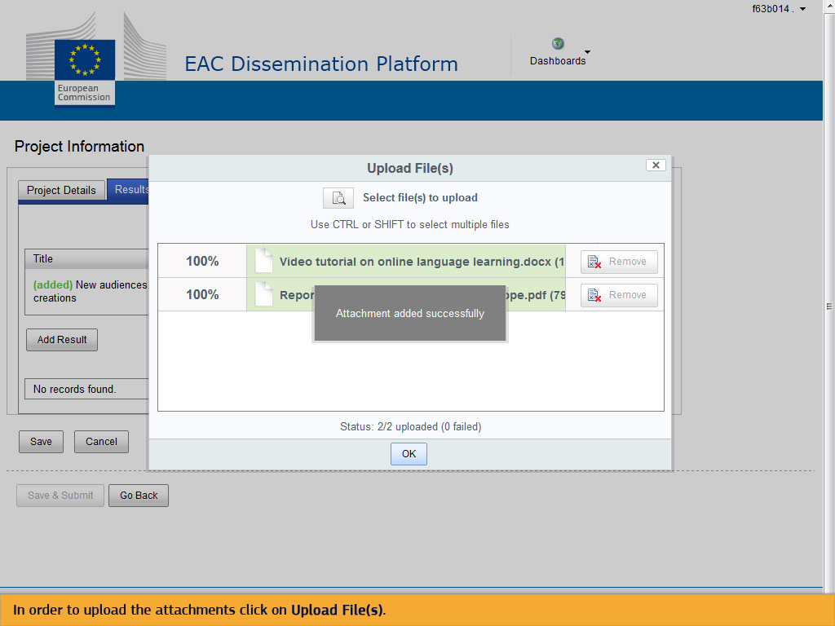
Text Captions

In order to upload the attachments click on Upload File(s).

Slide 67 - Slide 67
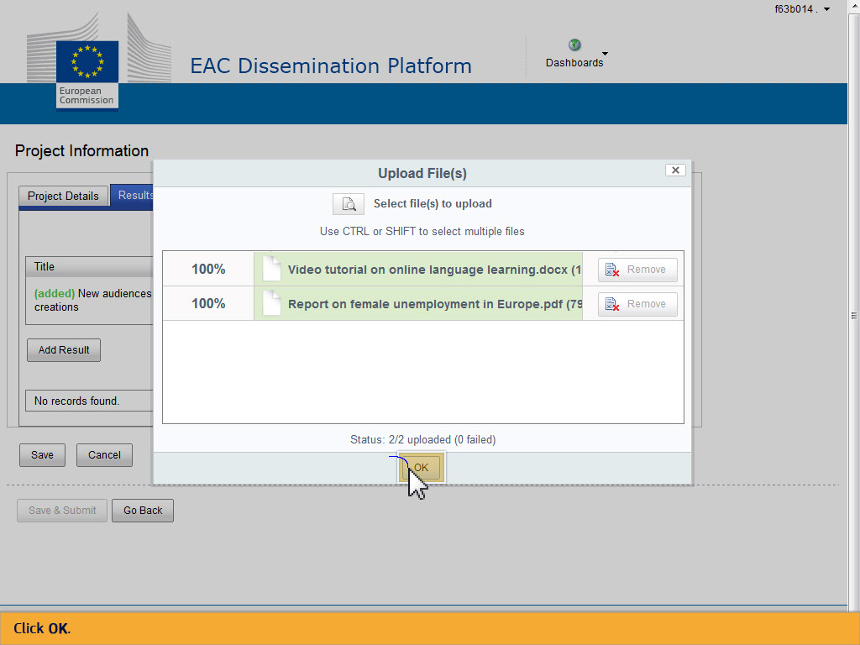
Text Captions

Click OK.

Slide 68 - Slide 68
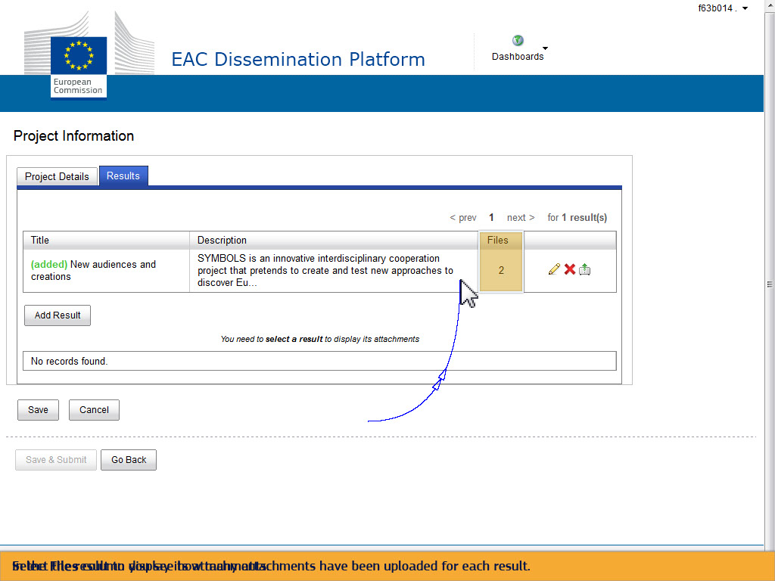
Text Captions

In the Files column you see how many attachments have been uploaded for each result.

Select the result to display its attachments.

Slide 69 - Slide 69
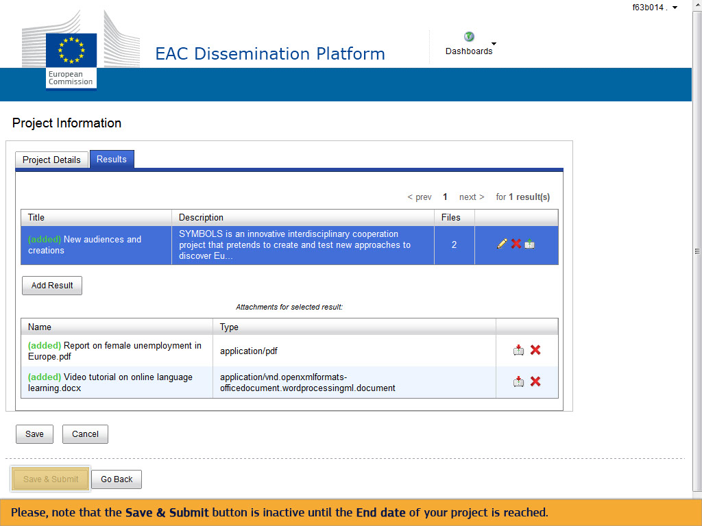
Text Captions

Please, note that the Save & Submit button is inactive until the End date of your project is reached.

Slide 70 - Slide 70
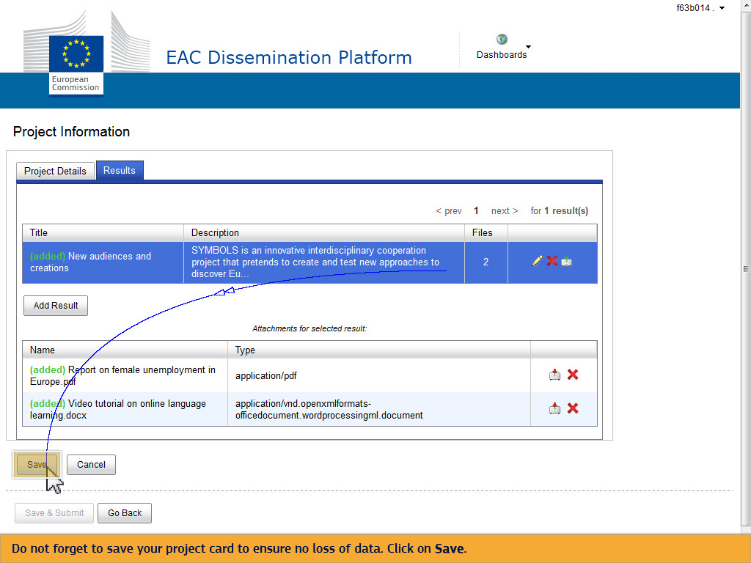
Text Captions

Do not forget to save your project card to ensure no loss of data. Click on Save.

Slide 71 - Slide 71
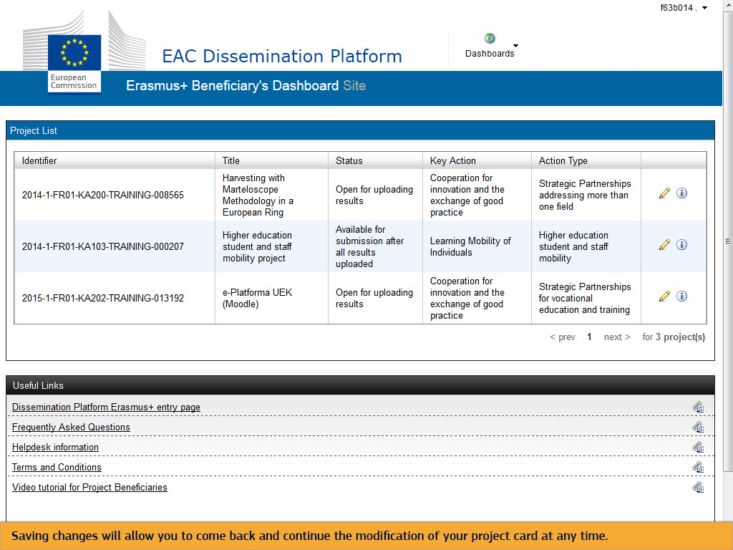
Text Captions

Saving changes will allow you to come back and continue the modification of your project card at any time.

Slide 72 - Slide 72
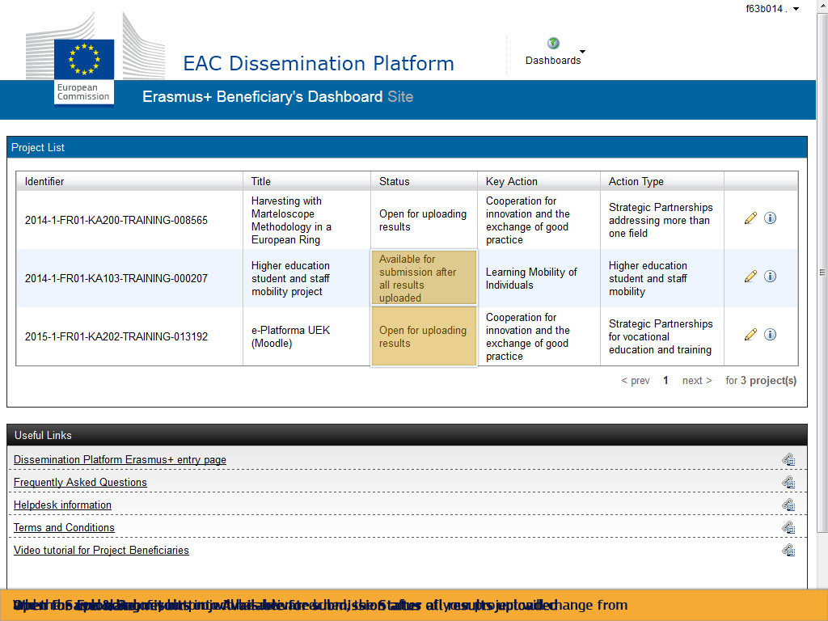
Text Captions

When the End date of your project has been reached, the Status of your project will change from Open for uploading results into Available for submission after all results uploaded and the Save & Submit button will be activated.

Slide 73 - Slide 73
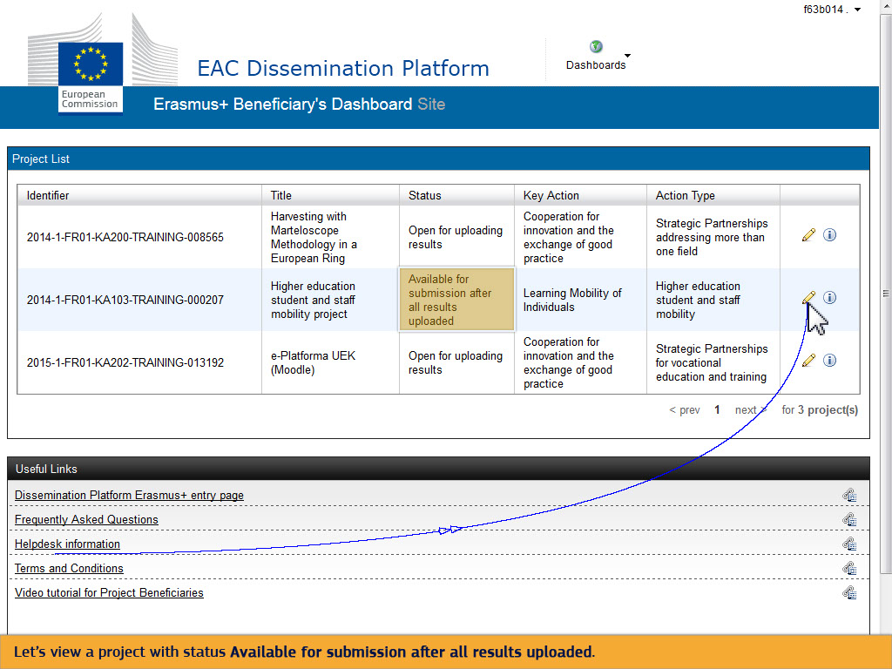
Text Captions

Let’s view a project with status Available for submission after all results uploaded.

Slide 75 - Slide 75
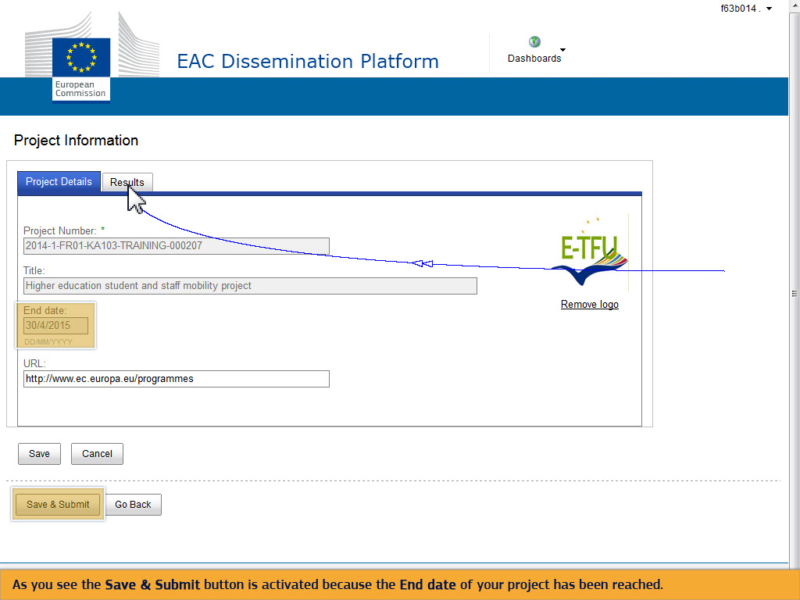
Text Captions

As you see the Save & Submit button is activated because the End date of your project has been reached.

Slide 76 - Slide 76
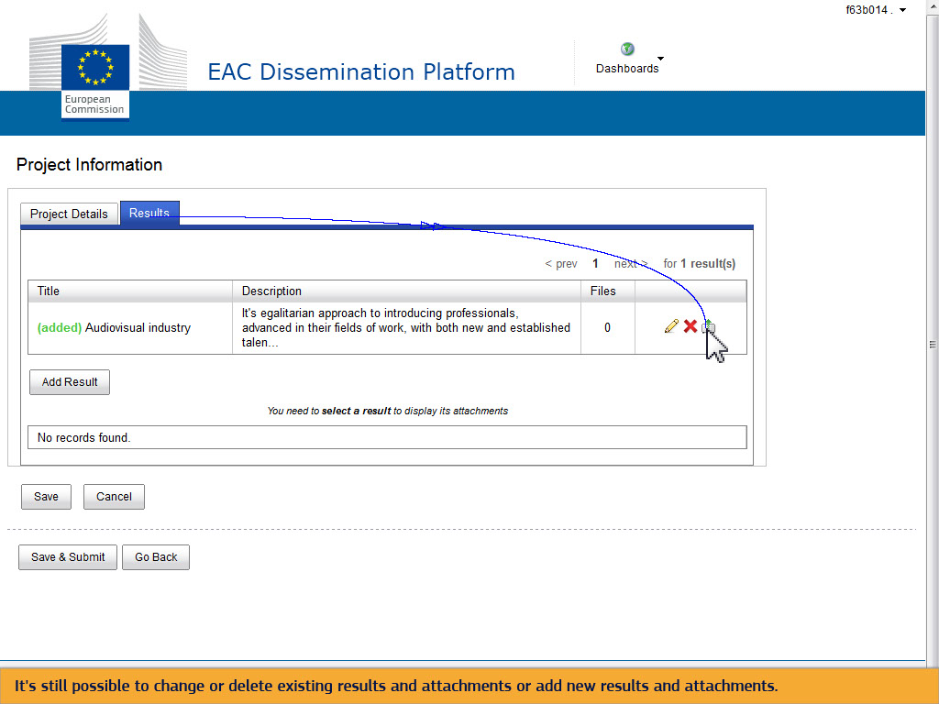
Text Captions

It's still possible to change or delete existing results and attachments or add new results and attachments.

Slide 77 - Slide 77
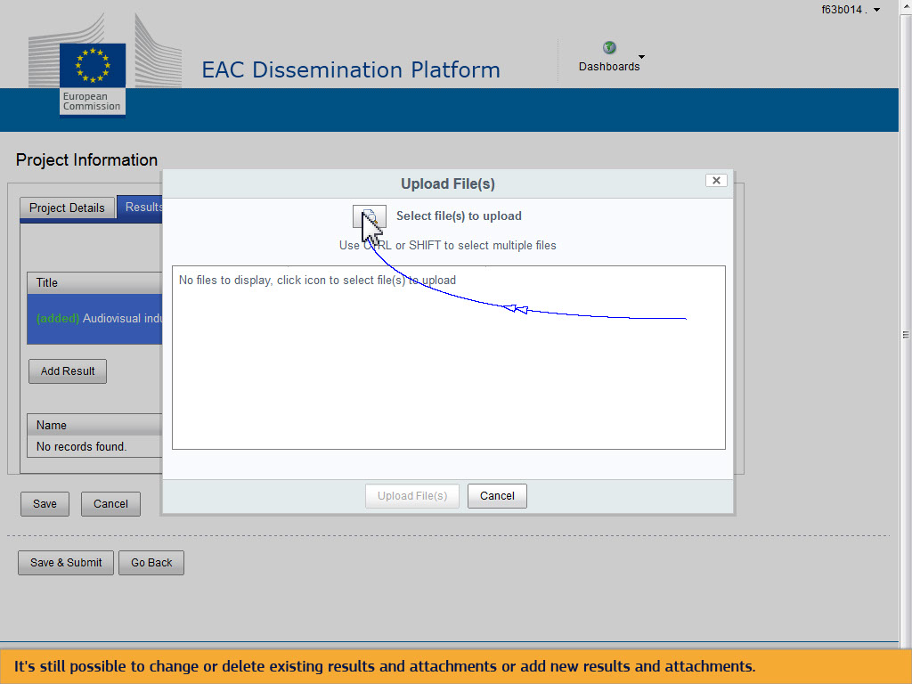
Text Captions

It's still possible to change or delete existing results and attachments or add new results and attachments.

Slide 78 - Slide 78
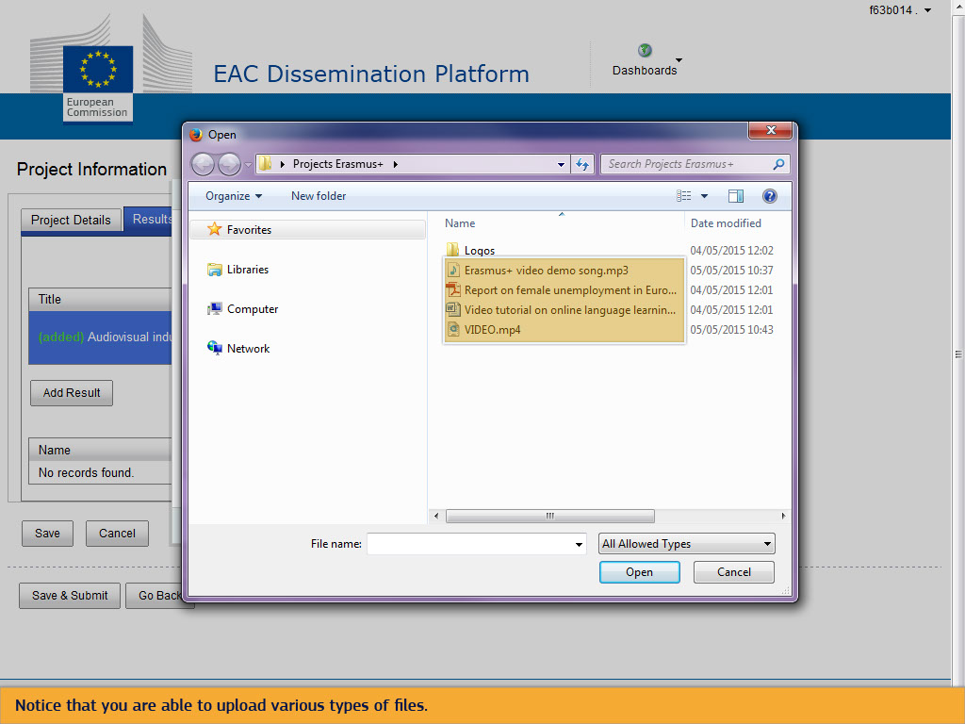
Text Captions

Notice that you are able to upload various types of files.

Slide 79 - Slide 79
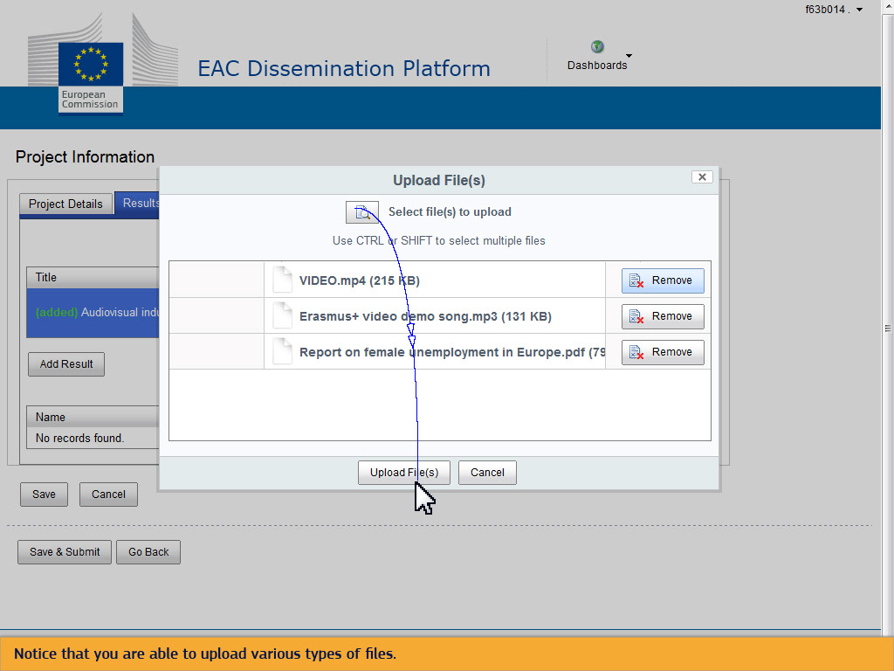
Text Captions

Notice that you are able to upload various types of files.

Slide 81 - Slide 81
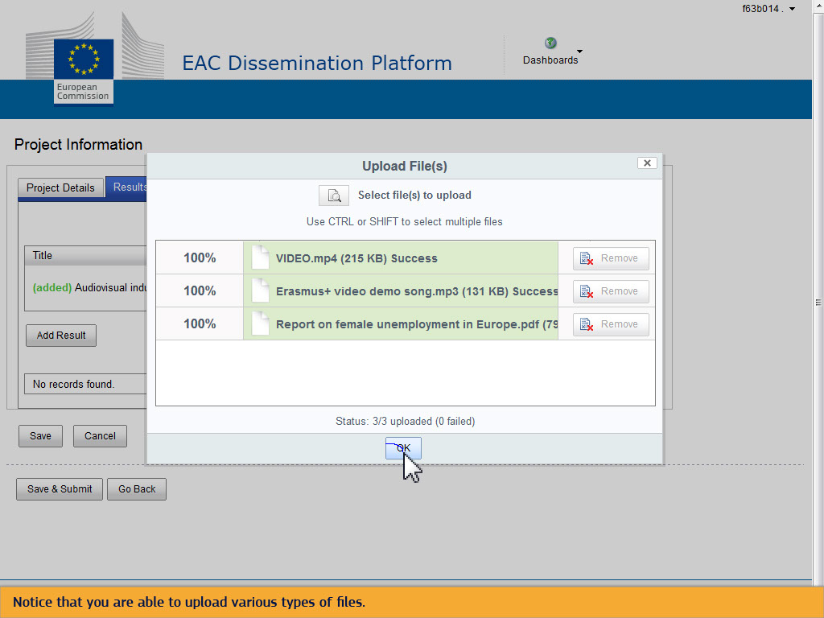
Text Captions

Notice that you are able to upload various types of files.

Slide 82 - Slide 82
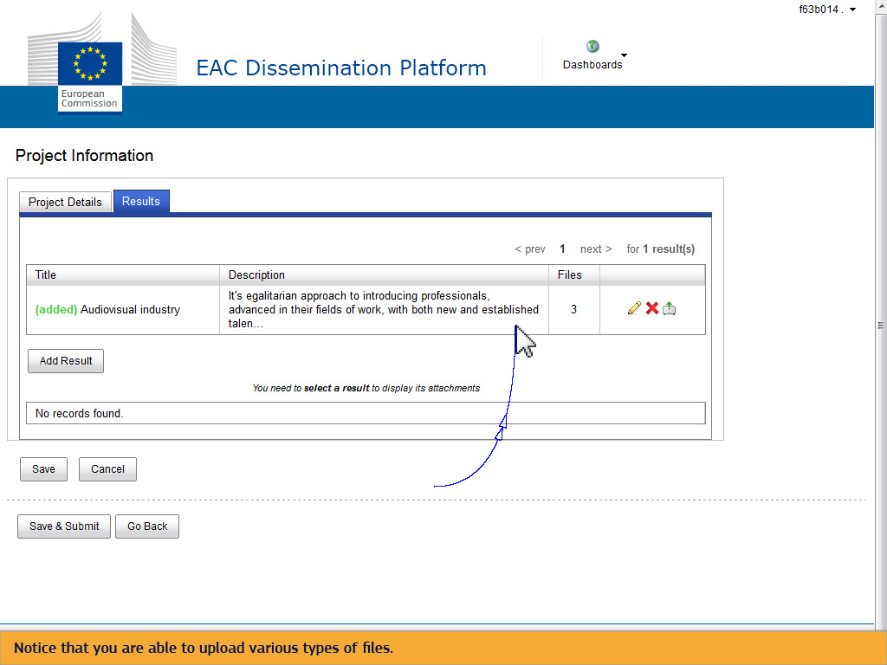
Text Captions

Notice that you are able to upload various types of files.

Slide 83 - Slide 83
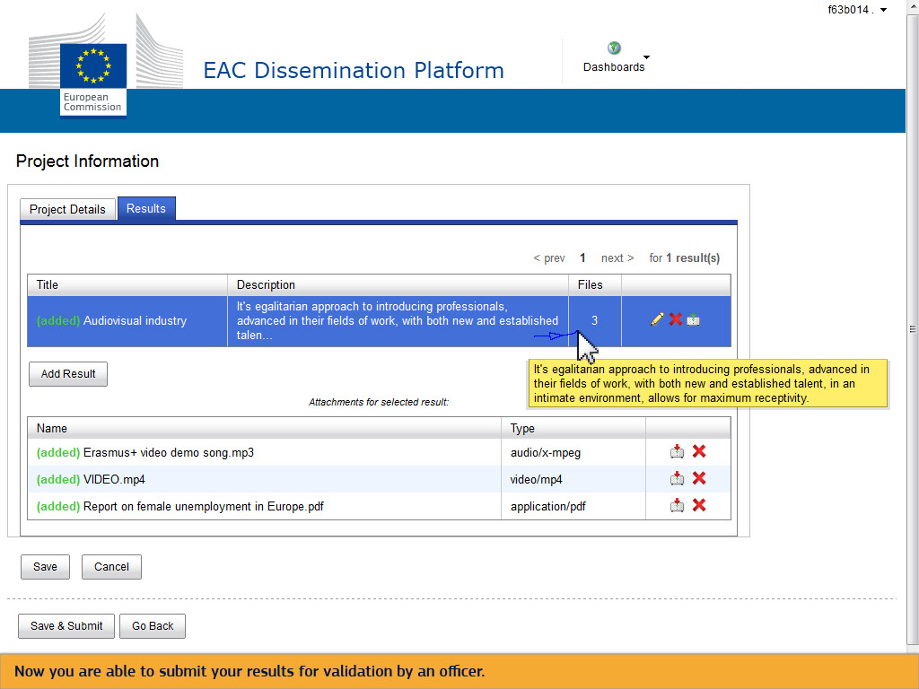
Text Captions

Now you are able to submit your results for validation by an officer.

Slide 84 - Slide 84
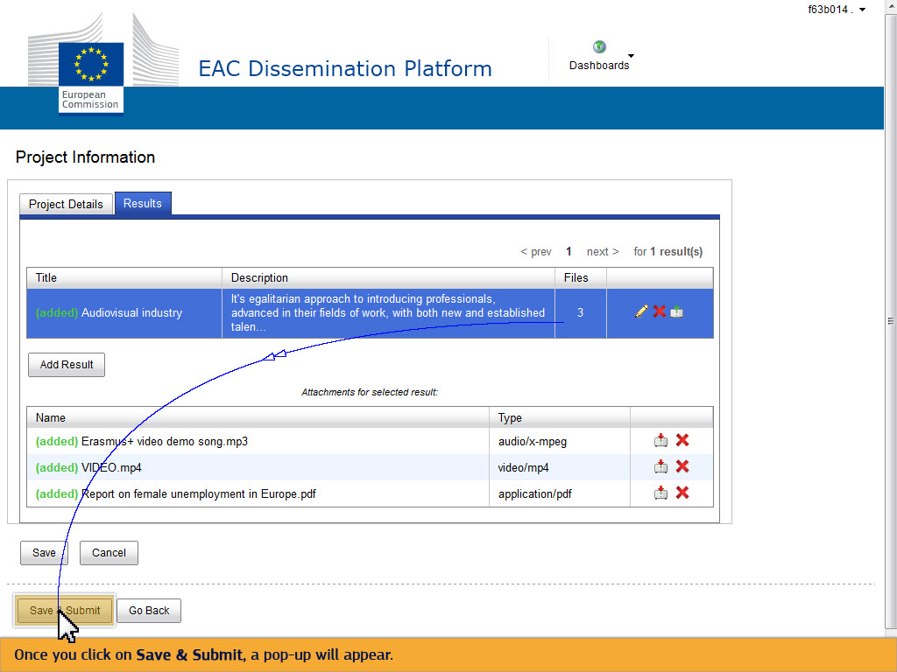
Text Captions

Once you click on Save & Submit, a pop-up will appear.

Slide 85 - Slide 85
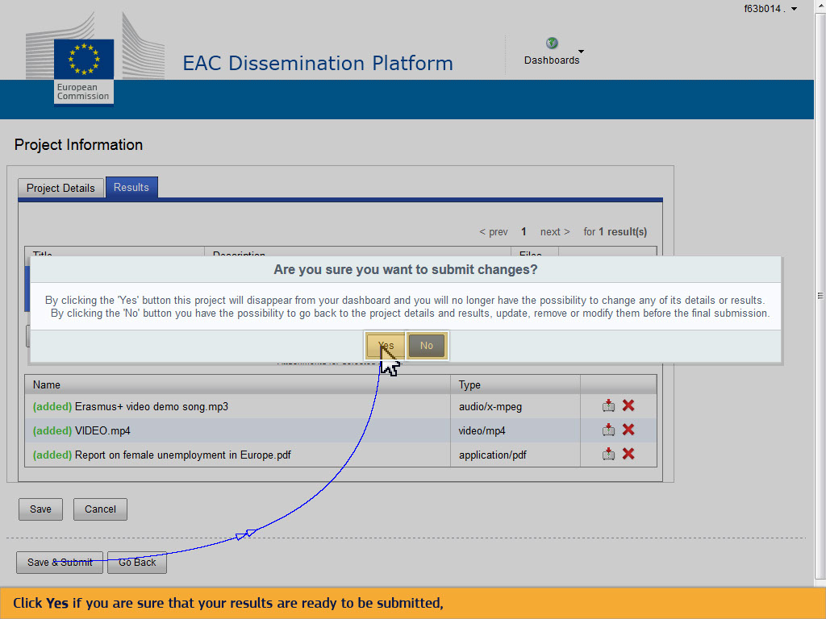
Text Captions

Click Yes if you are sure that your results are ready to be submitted, or No if you want to further elaborate on your project card.

Slide 88 - Slide 88
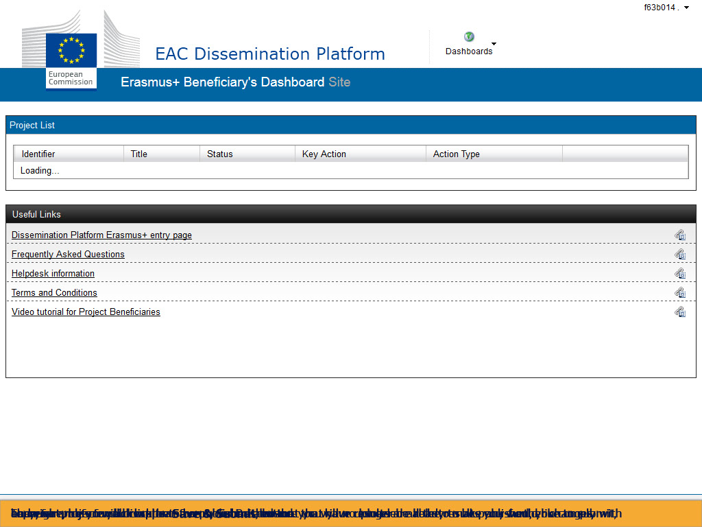
Text Captions

Before you click on Save & Submit, ensure that your results are ready to be published, you comply with copyright rules for all results to be published and that you have uploaded all the results you would like to submit, because once you click on the Save & Submit button you will no longer be able to make any further changes and your project will disappear from your Dashboard.

Slide 89 - Slide 89
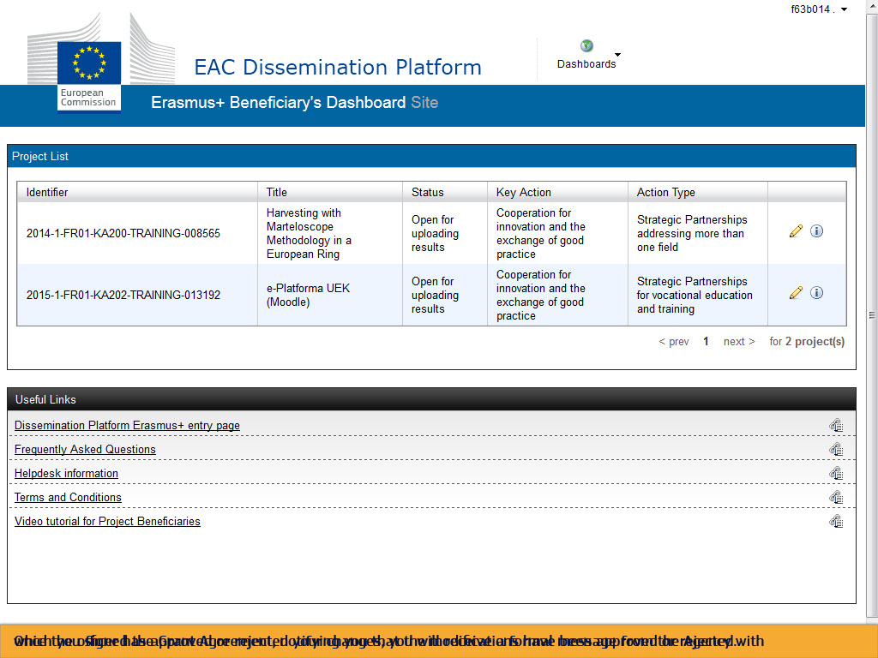
Text Captions

Once the officer has approved or rejected your changes, you will receive a formal message from the Agency with which you signed the Grant Agreement, notifying you that the modifications have been approved or rejected.

Slide 90 - Slide 90
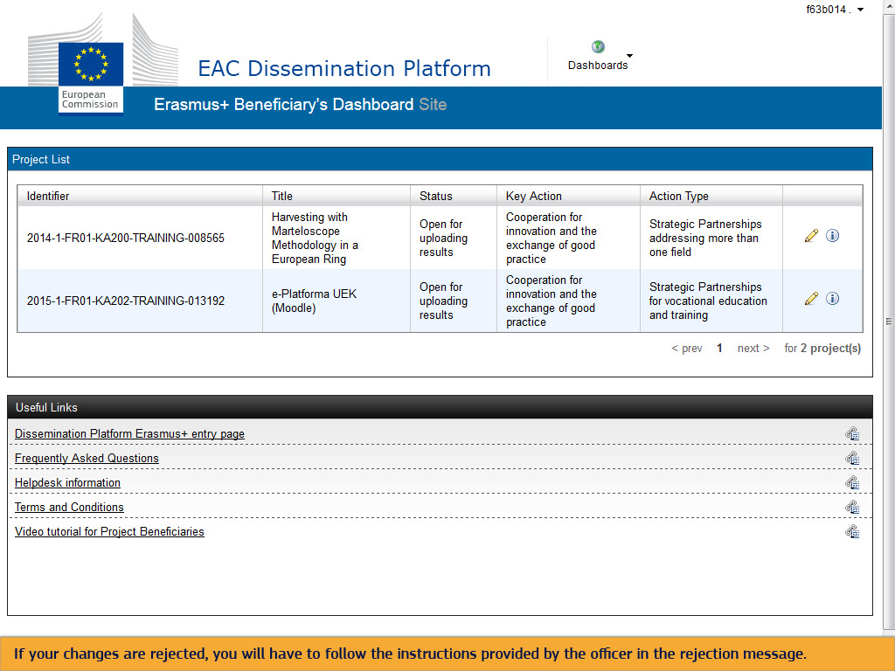
Text Captions

If your changes are rejected, you will have to follow the instructions provided by the officer in the rejection message.

Slide 91 - Slide 91
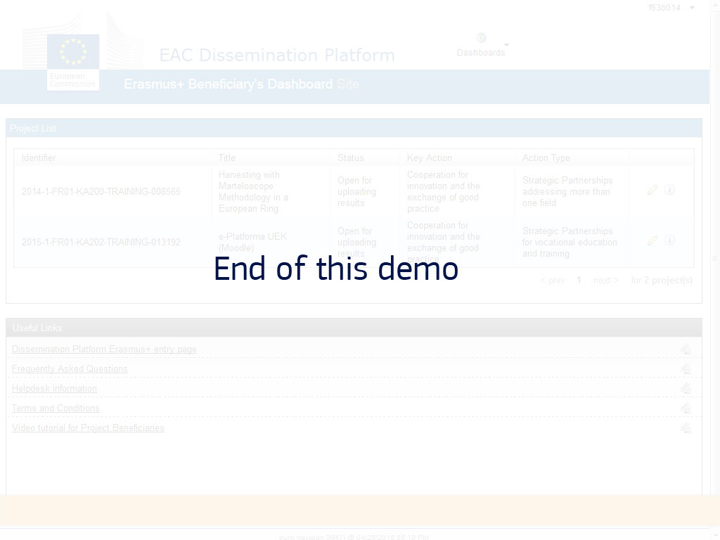
Text Captions

End of this demo

