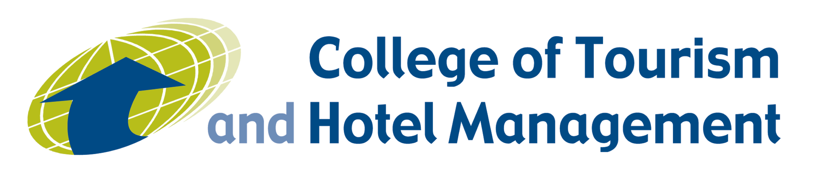

THE COLLEGE OF TOURISM AND HOTEL MANAGEMENT, NICOSIA, CYPRUS

The College of Tourism and Hotel Management is a private establishment of higher education, registered with the Cyprus Ministry of Education and Culture as a school of Higher (Tertiary) Education. It is co-educational and non-residential. The language of instruction is English.
The College of Tourism offers a variety of study programs, each of which stimulates and rewards its participants by providing knowledge and developing the skills necessary in today’s rapidly changing society. The underlying objective of all programmes is to prepare students for a successful career in business, tourism, hospitality and the service industries. The ease with which successful graduates of the College secure employment demonstrates the confidence shown in the College by the industry and the correctness of its educational policy.
The College of Tourism and Hotel Management is an internationally respected college offering career-oriented programs of study of superior quality. Each program is specifically designed to enable graduates to become highly sought-after in the international business arena. The College is authorized by the Cyprus Ministry and Education and Culture to offer the following full-time programs of study:

THE LIFELONG LEARNING PROGRAMME 2007-2013
ERASMUS

The Erasmus Office would be interested in creating a Bilateral (Inter-Institutional) Agreement for student, teacher and staff mobility with your institution.
The College has the extended Erasmus University Charter which allows us to participate in student work placements as well. We can collaborate under our four-year B.A. Hospitality Management programme for student mobility. We can also accept and send teachers from any department or teaching course. We also participate in staff training from all departments, e.g. accounts, student affairs, admissions, academic affairs etc. The College operates on a semester-basis whereby each semester is 30ECTS. Our incoming Erasmus students usually come for one semester and so far we have done the same for outgoing.

Apart from our registered B.A. programme, the College also offers diplomas in Travel and Tourism Administration, Hotel Management and the Postgraduate Diploma in
Business Administration. In addition, we would be happy to welcome and send lecturers who teach on the Masters in Business Administration programme.

For your information, the College publishes a journal ‘Tourism Today’ and the Editor-in-Chief welcomes research papers for publication in the journal. Please feel free to view past and current issues of the journal on our website www.cothm.ac.cy

The Erasmus Office looks forward to hearing from you soon with regards to a new and fruitful collaboration.

Please find below the contact details of the Erasmus Office and information on Erasmus at COTHM:

Erasmus Co-ordinator: | Helen Kouppas
College Address: | Larnaka Road  P.O.Box 20281  Aglangia, 2150  Nicosia, Cyprus
Telephone number: | 22462846  ext.230
Fax number: | 22336295
College website: | www.cothm.ac.cy
Email address: | erasmus@cothm.ac.cy

