EUROGUIDANCE CROSS BORDER SEMINAR
GUIDANCE CROSSING BORDERS
Retz, Austria, 8-10 June 2015
Motivation form

Why would you like to participate in the Cross Border Seminar? Explain what you would like to learn and how the topic of the seminar is related to your work? (max. 1800 characters)

__________________________________________________________________________
__________________________________________________________________________
__________________________________________________________________________
__________________________________________________________________________
__________________________________________________________________________
__________________________________________________________________________
__________________________________________________________________________
__________________________________________________________________________
__________________________________________________________________________
__________________________________________________________________________

How do you expect the experience and knowledge acquired at seminar to improve your further work as school counsellor? (max. 1800 characters)

__________________________________________________________________________
__________________________________________________________________________
__________________________________________________________________________
__________________________________________________________________________
__________________________________________________________________________
__________________________________________________________________________
__________________________________________________________________________
__________________________________________________________________________
__________________________________________________________________________
__________________________________________________________________________

Please provide a detailed dissemination plan, i.e. explain with whom and how you intend to share the information about the outcomes of this seminar, the experience and knowledge you have acquired – as specific as possible. Some of the eligible dissemination activities are workshops for pupils, a presentation for the school staff, a presentation for the members of the psychologists’ / pedagogues’ county council, etc. (max. 1800 characters).
__________________________________________________________________________
__________________________________________________________________________
__________________________________________________________________________
__________________________________________________________________________
__________________________________________________________________________
__________________________________________________________________________
__________________________________________________________________________
__________________________________________________________________________
__________________________________________________________________________
__________________________________________________________________________
__________________________________________________________________________

Please send this motivation form along with the application form and your Europass CV in English

• by e-mail to euroguidance@mobilnost.hr in PDF form. Subject of the e-mail: Prijava za Euroguidance prekogranični seminar, and

by registered mail to

Agencija za mobilnost i programe EU

Frankopanska 26

10000 Zagreb

s naznakom „Prijava za Euroguidance prekogranični seminar“

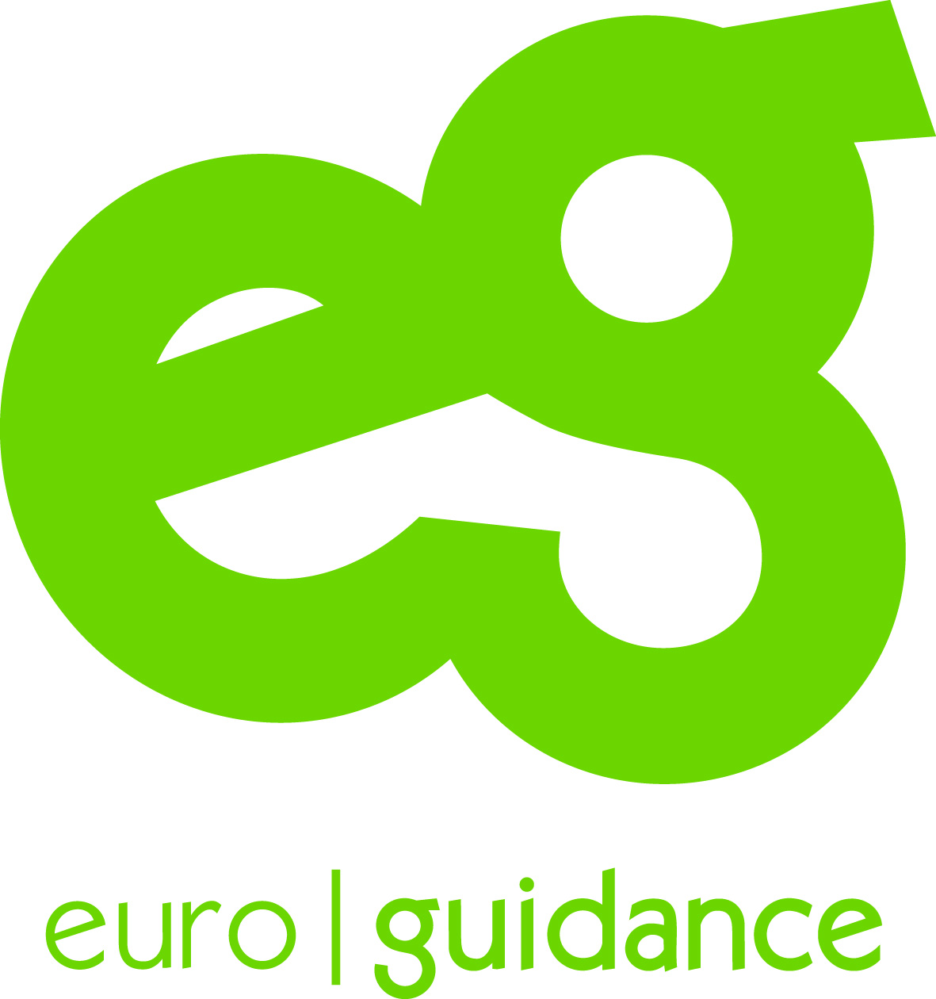
Deadline: 31 March 2015

